Intent-Aware Logic-Constrained Neuro-Symbolic Decision Support System with Trust Calibration for SME Multi-Channel Marketing

By

Ng Jing Yong



FACULTY OF COMPUTING AND
INFORMATION TECHNOLOGY

TUNKU ABDUL RAHMAN UNIVERSITY OF MANAGEMENT AND TECHNOLOGY
KUALA LUMPUR

ACADEMIC YEAR
2025/26

Intent-Aware Logic-Constrained Neuro-Symbolic Decision Support System with Trust Calibration for SME Multi-Channel Marketing

By

Ng Jing Yong

Supervisor: Mr. Low Choon Keat

A project report submitted to the
Faculty of Computing and Information Technology
in partial fulfillment of the requirement for the
Bachelor of Software Engineering (Honours)

Department of Software Engineering and Technology
Faculty of Computing and Information Technology
Tunku Abdul Rahman University of Management and Technology
Kuala Lumpur

Copyright by Tunku Abdul Rahman University of Management and Technology.
All rights reserved. No part of this project documentation may be reproduced, stored in retrieval system, or transmitted in any form or by any means without prior permission of Tunku Abdul Rahman University of Management and Technology.

Declaration
The project submitted herewith is a result of my own efforts in totality and in every aspect of the project works. All information that has been obtained from other sources had been fully acknowledged. I understand that any plagiarism, cheating or collusion or any sorts constitutes a breach of TAR University rules and regulations and would be subjected to disciplinary actions.

________NJY__________________
Ng Jing Yong
Bachelor of Software Engineering (Honours)
ID: 25WMR10019

Abstract
This is a one-page summary of the project (without any subheading) of usually not more than 300 words. It is often used to help the reader to quickly ascertain the documentation’s purpose. Like all summaries, abstract covers the main points of a piece of writing that includes the field of study, problem statement, methodology adopted, research process, conclusion and planning of the project work, etc. It helps readers understand the project by acting as a pre-reading outline of key points.
The contents that you may include in an abstract are as follows:
Purpose: Describes the main purpose of carrying the project, i.e. to justify the existence of the project by stating the existing problem to be solved. Explain why it is necessary to solve it and how the project contributes to the solution.
Scope: This covers areas or size of the project in terms of function and features of the system, modules or sub-modules involved, and functional areas covered in an organization.
Methodology: To describe the methodology, tools, techniques and models that are used throughout the project.
Testing criteria used: To describe the various assessment areas this project has undergone.
Results and Conclusion: To brief the outcome, strengths and weakness of the system or the entire project.
Note: Your abstract SHOULD NOT have bullet points or headings according to the contents listed above. Refer to abstracts of research papers for examples of abstracts.

Acknowledgement
First and foremost, I would like to express my deepest gratitude to my project supervisor, Mr. Low Choon Keat, for his continuous guidance, valuable advice, constructive feedback, and unwavering support throughout the duration of this Final Year Project. His insights and encouragement have greatly contributed to the successful completion of this project.
I would also like to sincerely thank the lecturers and faculty members of the Faculty of Computing and Information Technology, Tunku Abdul Rahman University of Management and Technology, for providing the necessary academic foundation, resources, and learning environment that enabled me to carry out this project effectively.
I would also like to express my sincere gratitude to my moderator, Dr. Chin Wan Yoke and Ms. Joan Hau, for her valuable guidance, constructive feedback, and continuous support throughout this research. Her insightful advice and recommendations have greatly contributed to the improvement and refinement of this study.
I am also grateful to the SME practitioners and individuals who participated, directly or indirectly, in providing feedback and insights for the evaluation of this project. Their contributions have helped strengthen the practical relevance of the proposed system.
Last but not least, I would like to thank my family for their endless love, patience, moral support, and encouragement throughout my academic journey. Their continuous motivation has been a great source of strength and inspiration.
This project would not have been possible without the support and contributions of all the individuals mentioned above. Thank you.

Table of Contents
Declaration ii
Abstract iii
Acknowledgement iv
Table of Contents v
1 Introduction 2
1.1 Background of the Study 3
1.2 Problem Statement 5
1.3 Research Questions 6
1.4 Research Aim and Objectives 7
1.5 Scope of the Study 7
1.6 Significance and AI Contribution 8
1.6.1 Practical Significance 8
1.6.2 Technical and Research Significance 9
1.6.3 AI Contribution 9
1.6.4 Proposed Approach Overview 11
1.7 Chapter Summary and Evaluation 11
2 Literature Review 14
2.1 Introduction 14
2.2 Theoretical or Conceptual Background 14
2.2.1 Marketing Analytics, Attribution and Prescriptive Decision Support 14
2.2.2 SME Strategic Intent and Human-in-the-Loop Decision Support 15
2.2.3 Neuro-Symbolic AI and Constraint-Aware Recommendation 16
2.2.4 Explainability, Trust Calibration and Appropriate Reliance 18
2.2.5 Literature-Derived Conceptual Framework 19
2.2.6 Design Requirements Derived from the Literature 20
2.3 Review of Related Work 20
2.3.1 Predictive, Attribution and Prescriptive Marketing Analytics 21
2.3.2 Intent-Aware and Constraint-Aware Decision Support 21
2.3.3 Explainability, Calibration and Human Reliance 22
2.3.4 Privacy, Security, Fairness and Deployment Constraints 23
2.4 Comparative Analysis 24
2.5 Research Gaps 26
2.6 Chapter Summary and Evaluation 27
3 Research Methodology 31
3.1 Research Design and Workflow 31
3.2 Dataset or Corpus 34
3.2.1 Data Collection and Sampling 35
3.2.2 Labelling and Annotation 36
3.2.3 Preprocessing 37
3.3 Data Splitting and Leakage Prevention 38
3.4 Proposed Approach 39
3.4.1 Predictive-Attribution Backbone 41
3.4.2 Candidate Action Generation 42
3.4.3 Weighted Soft-Rule Reasoning 42
3.4.4 Intent-Aware Decision Module 43
3.4.5 Trust Calibration Module 44
3.4.6 Structured Explanation Generation 44
3.5 Baseline Selection and Justification 46
3.5.1 Block 1 Baselines: Decision Recommendation Performance 46
3.5.2 Block 2 Baselines: Trust Calibration and Explanation 47
3.5.3 Block 3 Baselines: Logic-Constrained Consistency 48
3.5.4 Block 4 Baselines: Business-Intent Conditioning 48
3.5.5 Block 5 Explanation Controls 49
3.6 Evaluation Metrics and Acceptance Criteria 50
3.6.1 Recommendation-Performance Metrics 50
3.6.2 Scenario and Logical-Consistency Metrics 50
3.6.3 Calibration and Reliance Metrics 51
3.6.4 Explanation Metrics 51
3.6.5 Operational Metrics 52
3.6.6 Testing, Validation and Statistical Plan 53
3.6.7 Benchmark and Annotation Validation 53
3.6.8 Model and Data Validation 54
3.6.9 Logic and Conflict Validation 54
3.6.10 Calibration Validation 54
3.6.11 Human Evaluation Protocol 55
3.6.12 Software and Reproducibility Testing 55
3.7 Experimental Setup 56
3.7.1 Block 1: Source Audit and Baseline Decision Benchmark 56
3.7.2 Block 2: Trust Calibration and Appropriate Reliance 57
3.7.3 Block 3: Logic-Constrained Attribution-to-Action Consistency 58
3.7.4 Block 4: Intent-Conditioned Recommendation Study 58
3.7.5 Block 5: Explanation Template Variant 59
3.7.6 Run Order and Decision Gates 59
3.7.7 Software, Hardware and Versions 60
3.7.8 Software Versions 61
3.8 Ethics, Privacy and Reproducibility 63
3.8.1 Ethical Considerations 63
3.8.2 Privacy and Data Governance 63
3.8.3 Experimental Reliability and Reproducibility 63
3.8.4 Study Limitations and Validity 63
3.8.5 Reproducibility and Data Availability 64
3.8.6 Reproducibility Measures 64
3.9 Objective–Method–Evidence Mapping 65
3.10 Chapter Summary and Evaluation 67
4 Proposed Approach: Model and Framework Implementation 69
4.1 Overall Architecture or Framework Design 69
4.2 Data Pipeline Implementation 73
4.3 Proposed Method Implementation 78
4.3.1 Model Architecture and Components 78
4.3.2 Key Algorithms 89
4.4 Baseline Implementation 95
4.5 Experimental Environment and Configuration 96
4.6 Implementation Constraints 97
4.7 Chapter Summary and Evaluation 98
5 Experiments, Results and Discussion 101
5.1 Sub-section 1 Heading 101
5.1.1 Sub-subsection Heading 101
5.2 Sub-section 2 Heading 101
5.3 Sub-section 1 Heading 101
5.3.1 Sub-subsection Heading 101
5.4 Sub-section 1 Heading 102
5.4.1 Sub-subsection Heading 102
5.5 Chapter Summary and Evaluation 102
6 Conclusion and Recommendations 104
7.1 Summary 104
7.2 Achievements 104
7.3 Contributions 104
7.4 Limitations and Future Improvements 104
7.5 Issues and Solutions 104
References 105
Appendices 110

Chapter 1

Introduction

Introduction
Small and Medium Enterprises (SMEs) are increasingly leveraging multiple digital channels for their marketing activities. These channels encompass social media platforms, e-commerce systems, customer relationship management applications, online advertising networks, and transactional databases. This generates diverse data regarding customer behaviour, campaign exposure, engagement, acquisition costs, conversion rates, and revenue. While this data theoretically supports improved campaign planning and resource allocation, its mere availability does not automatically lead to better managerial decisions. This is particularly true for SMEs, which often contend with limited expertise, constrained budgets, and evolving market priorities (Wedel & Kannan, 2016).
Current marketing analytics solutions predominantly focus on prediction and attribution. Predictive models forecast future outcomes such as customer response, conversion likelihood, or campaign performance. Attribution models, on the other hand, estimate the relative contribution of different channels and touchpoints to business outcomes (Li & Kannan, 2014; Berman, 2018). These capabilities are undoubtedly valuable, as they help managers understand past events and anticipate future trends. However, they frequently stop at analytical interpretation, failing to consistently address the practical managerial question of what specific action should be taken after a prediction or attribution result is generated.
This limitation creates an "attribution-to-action gap." In this context, the attribution-to-action gap describes a situation where a system can identify influential marketing signals but struggles to translate them into transparent, feasible, and context-aware recommendation actions. For instance, an attribution model might reveal a strong channel contribution to conversions. Yet, the SME manager still faces the critical decision of whether to increase investment, maintain the current strategy, reduce spending, or delve deeper into the campaign. This decision cannot be based solely on attribution evidence, as it also depends on strategic intent, operational constraints, available budget, and acceptable risk.
This gap presents a more significant challenge for SMEs compared to large enterprises. SMEs often lack dedicated analytics teams and may rely on simplified dashboards or manual judgment. A recommendation suitable for a growth-oriented business, for example, may not be appropriate for a business prioritising short-term survival. A campaign with promising conversion potential might still be too risky if acquisition costs are high and the organisation needs to preserve cash flow. Conversely, a conservative recommendation could be detrimental when an organisation is deliberately focused on customer acquisition and market expansion. Therefore, SME marketing decision support requires not only prediction and attribution, but also intent-aware reasoning and explicit consideration of business constraints.
Artificial intelligence (AI) offers significant opportunities to enhance marketing decision support, though it also introduces challenges related to trust and accountability. Many machine learning models operate as "black boxes," making it difficult for users to comprehend the rationale behind a recommendation (Ribeiro et al., 2016). Explainable AI can improve transparency by identifying influential features or providing local explanations. Nevertheless, explanation alone may not guarantee appropriate reliance. Users might over-rely on incorrect recommendations when explanations appear convincing, or they might under-utilise reliable recommendations when uncertainty is not clearly communicated (Green & Chen, 2019; Schemmer et al., 2023; Vasconcelos et al., 2023).
Neuro-symbolic artificial intelligence offers a suitable foundation for this project by combining data-driven learning with explicit symbolic reasoning. Neural or machine learning components can learn patterns from marketing data, while symbolic components can represent business rules, constraints, and decision logic in a more interpretable format. This project operationalises the neuro-symbolic concept through a predictive-attribution backbone, a weighted soft-rule recommendation layer, an intent-aware decision module, a trust calibration module, and a structured explanation module. The goal is not to develop a fully autonomous marketing platform, but rather to create a bounded decision support system that assists human managers.
This project proposes an Intent-Aware Logic-Constrained Neuro-Symbolic Decision Support System with Trust Calibration for SME Multi-Channel Marketing. The system is designed to generate bounded recommendation actions, articulate the reasoning behind those actions, and provide calibrated confidence information. It operates as a human-in-the-loop system, where the manager reviews the recommendation, explanation, and confidence level before making the final decision. This approach preserves managerial accountability while enhancing the actionability and auditability of AI-assisted marketing decision support.

Background of the Study
Marketing decision support has evolved significantly, moving beyond simple descriptive reporting to embrace predictive and prescriptive analytics. While descriptive dashboards offer valuable summaries of past performance and predictive analytics forecasts future outcomes, a deeper understanding comes from attribution modelling, which clarifies how various channels and touchpoints contribute to business results. Although these tools are undeniably useful, they typically require managers to interpret complex analytical outputs and manually determine subsequent actions.
This interpretation process presents a particular challenge for small and medium-sized enterprises (SMEs) engaged in multi-channel marketing. Managers must simultaneously evaluate signals from diverse sources such as social media, e-commerce, advertising, and customer relationship management. They also need to balance multiple objectives, including customer acquisition, retention, profitability, cost control, and brand visibility. A system that merely reports performance indicators may reduce information uncertainty, but it falls short of providing actionable recommendations that align with specific intent and constraints.
This study specifically addresses this decision-support layer. The predictive-attribution component serves as an evidence generator, not the primary innovation. The core contribution lies in converting this analytical evidence into bounded, auditable, and trust-calibrated recommendation actions. The system, therefore, recommends whether a campaign should be increased, maintained, reduced, or investigated, based on predictive signals, attribution evidence, business intent, and soft-rule constraints.
Three bounded business intent scenarios have been defined for this project: survival, retention, and growth. Survival prioritises short-term stability, cash discipline, and risk reduction. Retention focuses on repeat purchases, customer value, and relationship maintenance. Growth emphasises customer acquisition and market expansion where potential benefits justify increased investment. These categories are intentionally limited to allow for a controlled and reproducible evaluation of intent-aware recommendation behaviour, rather than attempting to represent all possible SME strategies.
Business constraints are incorporated through weighted soft rules, rather than absolute hard rules. This approach is crucial because SME marketing decisions often involve multiple objectives. A hard-rule system could prematurely reject many feasible recommendations if even one condition is not fully met. A weighted soft-rule approach allows the system to balance predictive evidence, budget feasibility, channel saturation, margin protection, and intent compatibility. This design promotes graceful degradation and generates recommendations that are more readily justifiable.
Trust calibration is an integral part of our system, recognizing that a recommendation is only valuable when users understand both its rationale and its reliability. The system provides calibrated confidence levels and a structured explanation comprising four fixed components: driver, implication, action, and caveat. The driver elucidates the primary evidence supporting the recommendation, the implication clarifies its expected business impact, the action states the suggested response, and the caveat communicates any associated uncertainty or limitations. This structure enhances managerial understanding while preserving human accountability.

Problem Statement
Small and medium-sized enterprises (SMEs) are increasingly gathering marketing data from various digital platforms. However, many still lack a reliable method for transforming analytical results into practical and trustworthy decisions. While current tools can forecast outcomes or attribute channel contributions, they often fall short in supporting strategic alignment, considering business constraints, providing calibrated confidence, and ensuring auditability. This project directly addresses five interconnected challenges:
P1. Attribution-to-action gap. Predictive and attribution models effectively identify crucial marketing signals, yet they frequently fail to translate these signals into clear, actionable managerial directives such as "increase," "maintain," "reduce," or "investigate." This forces SME managers to manually interpret analytical outputs, which can lead to inconsistent decision-making.
P2. Limited strategic intent awareness. A recommendation appropriate for a growth-focused SME may be entirely unsuitable for one prioritizing survival. Existing systems often optimize for generic objectives, neglecting to explicitly model whether the business is prioritizing survival, retention, or growth. Consequently, recommendations, while technically sound, can be strategically misaligned.
P3. Limited integration of business constraints. Marketing decisions are profoundly influenced by factors such as budget availability, risk tolerance, margin protection, channel saturation, campaign policies, and operational capacity. Solely data-driven models may generate analytically appealing recommendations that are operationally unfeasible. A truly practical decision support system must, therefore, merge analytical evidence with explicit business reasoning.
P4. Explainability without calibrated trust. Explanations certainly enhance transparency, but they do not inherently convey the reliability of a recommendation. Without calibrated confidence, users might over-trust weak recommendations or, conversely, dismiss reliable ones. This becomes particularly critical when decisions involve financial expenditure, uncertainty, and managerial accountability.
P5. Limited auditability and managerial accountability. SME managers are required to justify marketing decisions, especially those involving financial investment and business risk. A decision support system that fails to record the evidence utilized, constraints applied, confidence levels, and explanations significantly hinders auditability and complicates future reviews.
The central research problem this project tackles is how to design and evaluate an SME marketing decision support system that transforms predictive and attribution evidence into recommendations that are consistent with intent, aware of constraints, and calibrated for trust, all while maintaining human oversight. Our proposed system addresses this by integrating predictive-attribution analysis, weighted soft-rule reasoning, business intent conditioning, calibrated confidence estimation, and structured explanation generation within a bounded software engineering prototype.

Research Questions
The project is guided by four research questions that correspond directly to the objectives and evaluation plan:
RQ1. Can an integrated predictive-attribution backbone with weighted soft-rule reasoning generate more actionable SME marketing recommendations than purely predictive or attribution-based baselines?
RQ2. Can calibrated confidence scores and structured explanations support more appropriate reliance on AI-assisted recommendations?
RQ3. Does business intent conditioning improve the contextual relevance of marketing recommendations across survival, retention and growth scenarios?
RQ4. Is the proposed system feasible for an FYP-scale prototype in terms of auditability, recommendation latency and implementation complexity?
RQ1 focuses on the attribution-to-action problem by examining whether the proposed reasoning layer improves recommendation quality. RQ2 focuses on trust calibration and explanation usefulness. RQ3 evaluates whether intent modelling produces contextually appropriate recommendations. RQ4 ensures that the system remains realistic within the technical and time constraints of a Final Year Project.

Research Aim and Objectives
This project focuses on the creation, refinement, and assessment of an intent-aware, logic-constrained neuro-symbolic decision support system. Its purpose is to deliver transparent, actionable, and trust-calibrated recommendations specifically for multi-channel marketing within small and medium-sized enterprises (SMEs).
To achieve this overarching goal, four distinct research objectives have been established:
RO1. To construct an anonymised and frozen benchmark dataset consisting of SME multi-channel marketing decision cases with predefined business intent scenarios. This objective ensures that the evaluation is performed on a stable set of decision cases and reduces the risk of arbitrary changes after experimentation begins.
RO2. To implement a predictive-attribution backbone integrated with a weighted soft-rule recommendation layer for generating intent-consistent marketing actions. The predictive-attribution component provides analytical evidence, while the soft-rule layer converts that evidence into recommendation actions constrained by business logic.
RO3. To develop a trust calibration and structured explanation module that communicates recommendation confidence, decision drivers, implications, actions and caveats. This objective addresses the need for both transparency and appropriate reliance when managers interact with AI-assisted recommendations.
RO4. To evaluate the proposed system against partial baselines in terms of recommendation actionability, scenario fit, logical consistency, calibration quality and interaction latency. This objective ensures that the proposed framework is assessed beyond prediction accuracy and is evaluated as a decision support system.

Scope of the Study
The project scope focuses exclusively on providing decision support for multi-channel marketing to Small and Medium-sized Enterprises (SMEs). This system rigorously analyses campaign-related data, generating precise, bounded recommendations. It meticulously applies business constraints, estimates confidence levels, and presents structured explanations for each recommendation. To ensure consistency, audibility, and suitability for controlled evaluation, the recommendation action space is deliberately confined to "increase," "maintain," "reduce," and "investigate."
The scope of this project encompasses data preprocessing, predictive-attribution analysis, candidate action generation, weighted soft-rule reasoning, intent-aware decision modelling, trust calibration, and structured explanation generation. We will also evaluate the system against baseline or ablation configurations. This system will function as a prototype, demonstrating the decision support workflow and generating evidence to evaluate the quality of its recommendations.
The excluded scope includes autonomous execution of marketing campaigns, direct integration with live enterprise systems, real-time streaming analytics, automatic legal or regulatory decision-making, unrestricted generative marketing content and autonomous learning of business rules. The symbolic rules are predefined and remain under developer control. These exclusions are necessary to maintain FYP feasibility and to ensure that the project does not overclaim beyond its implementation and evaluation capacity.
The target users for this system are SME owners, marketing managers, or campaign executives who require assistance in interpreting multi-channel marketing evidence. The system is not intended to replace these users. Instead, it offers decision support by presenting a recommended action, the underlying reasoning, and a confidence level to guide human review. Ultimate decision-making authority always remains with the human user.

Significance and AI Contribution
This project is significant because it addresses the difficulty faced by small and medium-sized enterprises in converting multi-channel marketing analytics into clear and defensible managerial actions. Existing analytical tools can provide predictions, attribution results and campaign performance indicators, but SME managers may still need to interpret these outputs manually before deciding whether to increase, maintain, reduce or investigate a campaign. This process can be challenging when decisions must also account for limited budgets, business priorities, operational constraints and uncertainty.

Practical Significance
The proposed system is intended to support SME owners, marketing managers and campaign executives who may not have access to specialised analytics teams. It reduces the interpretation burden by presenting a bounded marketing action together with its supporting evidence, confidence level and explanation.
The system does not execute marketing actions automatically. Instead, it supports human decision-making by helping managers understand what action is recommended, why it is recommended and when further review may be necessary. This preserves managerial responsibility while improving the consistency, transparency and auditability of marketing decisions.
The practical value of the project is expected to be demonstrated through the usefulness, clarity, contextual relevance and response time of the generated recommendations.

Technical and Research Significance
The technical significance of the project lies in combining data-driven marketing analysis with explicit business reasoning. Rather than treating predictive or attribution results as final decisions, the proposed system uses these results as evidence for generating constraint-aware and intent-aware recommendations.
The research significance lies in investigating the attribution-to-action gap in SME multi-channel marketing. The project examines whether integrating predictive evidence, business constraints, strategic intent, confidence communication and structured explanation can produce recommendations that are more actionable and contextually appropriate than simpler analytical approaches.
The project also provides a bounded evaluation setting using predefined business intents and recommendation actions. This allows the contribution of the proposed AI approach to be assessed in a controlled and measurable manner.

AI Contribution
The AI task in this project is intent-aware and constraint-aware marketing action recommendation. The system receives structured campaign data and produces one bounded managerial recommendation from the action set Increase, Maintain, Reduce and Investigate. The recommendation is generated using both learned evidence and explicit symbolic reasoning.
The input to the AI pipeline includes campaign characteristics and performance indicators such as marketing channel, impressions, clicks, leads, conversions, revenue, acquisition cost, return on investment, engagement score, customer segment and campaign date. Derived indicators such as click-through rate, conversion rate, cost per acquisition, revenue per conversion, ROI band and engagement band may also be used. In addition, the system receives a declared business-intent label—Survival, Retention or Growth—and applies predefined business constraints during recommendation scoring.
The neural or data-driven component is represented by the predictive-attribution backbone. This component learns relationships between campaign characteristics and marketing outcomes, producing prediction scores and attribution-related evidence. The symbolic component is represented by weighted soft-rule reasoning. It evaluates candidate actions against explicit business rules and constraints while allowing partial satisfaction and trade-offs. This combination forms the neuro-symbolic AI contribution of the project.
The use of weighted soft rules is important because SME marketing decisions are not always governed by absolute conditions. A campaign may slightly exceed a preferred cost threshold but still justify additional investment under a Growth intent when the projected return is sufficiently strong. Conversely, the same campaign may require a more conservative recommendation under a Survival intent. Weighted reasoning allows the system to balance competing evidence instead of rejecting an action immediately when one condition is not fully satisfied.
The intent-aware decision module further differentiates the system from a generic prediction or recommendation model. Under Survival, greater importance is assigned to cost control, margin protection, cash preservation and risk reduction. Under Retention, greater emphasis is placed on customer value, engagement quality and repeat-purchase indicators. Under Growth, the system places greater weight on acquisition potential, conversion momentum and scalable channel performance. Therefore, the recommendation is conditioned on both the campaign evidence and the organisation’s current strategic priority.
Trust calibration forms another explicit AI contribution. Raw model probabilities may be overconfident or underconfident, which can mislead users about recommendation reliability. The system applies temperature scaling using validation data to produce calibrated confidence estimates. The calibration quality is evaluated using Expected Calibration Error. The confidence score is then incorporated into the explanation so that low-confidence recommendations encourage further investigation rather than immediate acceptance.
The final explanation is generated in a structured format containing four components:
- Driver identifies the strongest evidence or activated rule supporting the recommendation.
- Implication translates the evidence into a business consequence.
- Action states the recommended managerial response.
- Caveat communicates uncertainty, risk, assumptions or limitations.
The AI contribution is therefore not merely the use of a machine learning model or the display of campaign analytics. It is the integration of predictive evidence, attribution information, weighted symbolic constraints, strategic intent, calibrated confidence and structured explanation to generate recommendations that are actionable, context-aware, auditable and suitable for human review.

Proposed Approach Overview
The proposed system accepts campaign-related inputs such as performance indicators, channel information, business constraints and the selected business intent. These inputs are analysed to generate predictive and attribution evidence. The evidence is then evaluated against business rules and strategic priorities before a final recommendation is produced.
The system output consists of:
- a recommended marketing action;
- supporting decision evidence;
- a confidence indication;
- and a structured explanation.
The final decision remains with the SME manager. Detailed information concerning dataset preparation, model design, rule formulation, calibration, baseline comparison and evaluation procedures is presented in Chapter 3, while the system architecture and implementation design are discussed in Chapter 4.

Chapter Summary and Evaluation
This chapter outlined the project's motivation, aim, research questions, problem statement, expected contributions, scope, and development approach. A core assertion of this work is that marketing decision support for SMEs necessitates more than just predictive accuracy or attribution measurement. Recommendations must align with strategic intent, adhere to business logic, be supported by calibrated confidence, and be presented in a format readily reviewable by managers.
The proposed system addresses these requirements by integrating predictive-attribution evidence with weighted soft-rule reasoning, intent-aware decision modelling, trust calibration, and structured explanations. This project is confined to an FYP-scale prototype. We have deliberately excluded autonomous campaign execution, enterprise-scale integration, and unrestricted automated marketing decisions. These boundaries ensure project feasibility while still delivering substantial technical and research contributions.
Chapter 2 provides a comprehensive literature review covering marketing analytics, attribution models, neuro-symbolic artificial intelligence, explainable AI, trust calibration, and human-AI decision support. This review establishes the detailed theoretical foundation for the chosen components and further substantiates the research gaps introduced in this chapter. Subsequent chapters will then translate these gaps into an implementable and evaluable decision support framework through a detailed methodology and system design.

Chapter 2

Literature Review

Literature Review

Introduction
This chapter examines the research streams that support an intent-aware logic-constrained neuro-symbolic decision support system with trust calibration for SME multi-channel marketing. The discussion is organised by technical problem: converting marketing analytics into action, modelling SME strategic intent, combining predictive evidence with symbolic constraints, calibrating trust in human-AI decision-making, and positioning the proposed framework against related approaches. This structure makes the literature review directly traceable to the Chapter 1 problem statement and the methodology in Chapter 3.
The central claim developed in this chapter is that SME marketing decision support cannot be solved by prediction, attribution, explanation or calibration alone. Prediction and attribution provide evidence about campaign performance and channel contribution, but they do not decide the next managerial action. Symbolic rules can represent business constraints, but strict rules may be too rigid for multi-objective marketing decisions. Explanations improve transparency, but they do not necessarily communicate reliability. A stronger solution therefore requires an integrated decision-support pipeline that combines evidence, constraints, strategic intent, calibrated confidence and structured explanation.

Theoretical or Conceptual Background

Marketing Analytics, Attribution and Prescriptive Decision Support
Marketing analytics provides the evidence base for data-driven marketing decisions. Descriptive analytics summarises campaign performance, diagnostic analytics explains observed outcomes, predictive analytics estimates future customer or campaign behaviour, and prescriptive analytics recommends possible actions. In multi-channel marketing, these capabilities are important because customer interactions are distributed across social media, e-commerce platforms, advertising networks, customer relationship management systems and transaction records. The ability to analyse these signals can improve campaign planning and resource allocation (Wedel & Kannan, 2016; Lepenioti et al., 2020).
Attribution modelling is particularly relevant because it estimates the contribution of channels and touchpoints to marketing outcomes. Li and Kannan (2014) model conversions in a multichannel environment, while Berman (2018) examines online advertising attribution beyond last-touch logic. These studies provide strong foundations for measuring channel contribution, yet their main outcome remains analytical insight. They help managers understand which channels or touchpoints matter, but they do not fully specify which bounded action should be taken after the attribution result is obtained.
This limitation is the attribution-to-action gap. An attribution model may indicate that a channel contributes strongly to conversion, but the SME manager still needs to decide whether to increase spending, maintain the strategy, reduce allocation or investigate inconsistent performance. That decision depends on budget availability, acquisition cost, margin pressure, channel saturation, risk level and business intent. Therefore, attribution evidence must be interpreted through a decision-support layer before it becomes a practical recommendation.
Prescriptive analytics moves closer to the problem because it focuses on recommending actions. Lepenioti et al. (2020) describe prescriptive analytics as a progression beyond prediction towards decision recommendation. However, many prescriptive approaches assume that objectives and constraints are well-defined. SME marketing decisions are often less formalised. The same campaign evidence can support a conservative action under a survival intent and an expansion action under a growth intent. This weakens the suitability of generic optimisation as a complete solution.
Recent AI marketing literature also shows that AI can support targeting, personalisation, customer segmentation and campaign optimisation, but successful use depends on data quality, context and managerial interpretation (Haleem et al., 2022). This project therefore treats AI as a decision-support mechanism rather than an autonomous marketing authority. The predictive-attribution backbone supplies evidence, while the recommendation layer converts that evidence into auditable actions under explicit business conditions.
The direct implication for the proposed framework is that predictive and attribution models should not be treated as final decision makers. They should provide signals that are subsequently processed by candidate action generation, weighted soft-rule reasoning and intent-aware decision modelling. This preserves the value of analytics while addressing the missing action layer identified in the literature.

SME Strategic Intent and Human-in-the-Loop Decision Support
SME marketing decisions differ from large-enterprise marketing decisions because SMEs often operate with smaller budgets, fewer specialist analysts and higher sensitivity to campaign failure. A large organisation may absorb experimental spending or maintain a specialised analytics team, whereas an SME may need to make fast and defensible marketing decisions using limited data and expertise. As a result, a technically sophisticated analytics system can still be unsuitable if the output is not actionable, interpretable and aligned with the current business priority.
Strategic intent is therefore not a secondary feature; it changes how evidence should be interpreted. A campaign with positive engagement and conversion potential may justify expansion when the organisation is pursuing growth, but the same campaign may require caution when the organisation is focused on short-term survival. Similarly, a retention-oriented business may value repeat purchase and customer relationship indicators more heavily than acquisition metrics. This means that recommendation quality depends on both analytical evidence and the strategic condition under which the recommendation is made.
The proposed project operationalises this issue through three bounded intent scenarios: survival, retention and growth. Survival emphasises cash preservation, margin protection and risk reduction. Retention emphasises repeat purchase, customer value and relationship maintenance. Growth emphasises customer acquisition and market expansion when the potential reward justifies higher risk. These scenarios are intentionally limited so that the recommendation process can be evaluated consistently across controlled decision cases.
The literature on decision support systems supports this human-in-the-loop framing. Decision support systems are designed to combine data, analytical models and human judgement for semi-structured decisions (Power, 2002). SME marketing decisions fit this category because some evidence is measurable, but the final decision still requires judgement about feasibility, risk and business context. This supports the decision to design the proposed system as an advisory tool rather than an autonomous campaign execution platform.
Strategic intent becomes an input to the system and an evaluation target. The intent-aware module adjusts recommendation priorities according to whether the scenario is survival, retention or growth. Scenario-fit rate then evaluates whether recommended actions are suitable for the selected intent. This design makes strategic alignment observable rather than rhetorical, and it connects the literature review directly to the methodology chapter.

Neuro-Symbolic AI and Constraint-Aware Recommendation
Neuro-symbolic artificial intelligence combines the pattern-recognition strength of neural or statistical learning with the explicit reasoning capability of symbolic systems. This direction is relevant because modern machine learning models can learn complex relationships from data but often provide limited support for transparent constraint handling. Symbolic systems can encode domain knowledge, business policies and decision rules, but may be too rigid or difficult to scale when used alone. Combining these approaches offers a way to connect data-driven evidence with explicit reasoning (Garcez & Lamb, 2023; Shakarian et al., 2023).
The proposed framework adopts a pragmatic neuro-symbolic pipeline. The predictive-attribution backbone functions as the data-driven evidence component. It analyses campaign indicators such as impressions, clicks, conversions, revenue, acquisition cost, return on investment and engagement. The symbolic component is implemented through weighted soft rules that evaluate candidate actions against constraints such as budget feasibility, margin protection, channel saturation and intent compatibility. The final recommendation is therefore not produced by prediction alone; it is shaped by explicit reasoning.
This design addresses a limitation of pure machine learning recommendation. A model may estimate that a campaign has high conversion potential, but this does not guarantee that increasing investment is feasible. If acquisition cost is excessive, the campaign is near saturation or the selected business intent is survival, a more conservative action may be appropriate. Symbolic reasoning makes these constraints visible and testable rather than leaving them to informal manual interpretation after the prediction is produced.
Hard-rule reasoning also has limitations. Marketing decisions are rarely governed by absolute rules. A campaign may slightly exceed a preferred cost threshold but still be acceptable if projected revenue is high and the business intent is growth. Conversely, a campaign may satisfy a performance threshold but remain unsuitable when it conflicts with risk or budget constraints. Weighted soft-rule reasoning is therefore more appropriate than strict rule rejection because it supports partial satisfaction, trade-offs and graceful degradation.
Constraint-based recommender systems show the value of explicitly modelling requirements during recommendation, although they require careful representation of constraints and preferences (Felfernig et al., 2015). Probabilistic soft logic and related approaches also demonstrate how uncertain or partially satisfied rules can support reasoning under imperfect knowledge (Pryor et al., 2023). These sources justify the use of weighted soft rules as a method-defining component in the proposed system, even though the project is applied specifically to SME marketing.
A further advantage of the neuro-symbolic pipeline is auditability. In a purely black-box recommendation model, the manager may see only the output. In the proposed architecture, a recommendation can be traced from predictive evidence to candidate action, rule score, intent adjustment, confidence estimate and explanation. This traceability is important for marketing decisions involving expenditure because the basis of the recommendation should be reviewable after the decision is made.

Explainability, Trust Calibration and Appropriate Reliance
Trust is central to AI-assisted decision support because the usefulness of a recommendation depends on appropriate reliance. Overtrust may cause a manager to accept an unreliable recommendation and allocate resources inefficiently. Undertrust may cause a manager to reject a useful recommendation and miss a viable opportunity. The trust in automation literature therefore argues that trust should be calibrated to system capability rather than maximised unconditionally (Lee & See, 2004).
Explainable AI addresses part of this problem by helping users understand why a model produced a result. Ribeiro et al. (2016) introduced local explanation methods for black-box predictions, while Barredo Arrieta et al. (2020) provide a broad taxonomy of explainable AI concepts, opportunities and challenges. In SME marketing, explanations can help managers understand whether a recommendation is driven by conversion, revenue, acquisition cost, engagement or channel performance. However, an explanation does not necessarily state how reliable the recommendation is.
Human-AI interaction research shows that explanations can influence reliance, but they do not automatically guarantee better decisions. Green and Chen (2019) demonstrate limits of algorithm-in-the-loop decision-making, while Schemmer et al. (2023) conceptualise appropriate reliance as accepting correct AI advice and rejecting incorrect advice. This distinction is crucial because a clear explanation may still accompany an unreliable recommendation. Explanation quality and confidence reliability must therefore be considered together.
Calibration research provides the technical basis for reliability communication. Guo et al. (2017) show that modern neural networks can produce poorly calibrated confidence estimates, where reported confidence does not match observed accuracy. Expected Calibration Error is commonly used to measure the mismatch between confidence and correctness across reliability bins. In this project, calibration is used not only as a technical metric but also as a decision-support signal that helps managers decide how much reliance to place on a recommendation.
Recent studies also separate subjective trust from behavioural reliance. Vasconcelos et al. (2023) show that explanations can reduce overreliance in AI-assisted decisions, while Scharowski et al. (2023) emphasise that trust and reliance should not be treated as identical constructs. This means that evaluating the proposed system should go beyond asking whether users trust it. The evaluation should examine whether users understand the recommendation, whether the confidence level is meaningful and whether the caveat discourages blind acceptance of low-confidence outputs.
The proposed explanation format therefore uses four standardised components: driver, implication, action and caveat. The driver states the main evidence behind the recommendation. The implication translates that evidence into business meaning. The action states the recommended response. The caveat communicates uncertainty, risk or boundary conditions. This format shifts explanation from a purely technical feature-attribution output to a managerial decision-support explanation.
Structured explanation and trust calibration are complementary. A confidence score without an explanation is difficult to interpret, while an explanation without calibrated confidence may create misplaced certainty. By combining both, the proposed system supports appropriate reliance and auditability. This directly motivates the use of Expected Calibration Error, trust alignment gap, overtrust rate and explanation usefulness in the methodology.

Literature-Derived Conceptual Framework
The final conceptual framework contains five linked layers. The first layer is the evidence layer, where marketing data are processed to produce predictive and attribution-related signals. The second layer is the candidate action layer, where evidence is translated into actions such as increase, maintain, reduce or investigate. The third layer is the reasoning layer, where weighted soft rules evaluate whether candidate actions fit constraints and intent conditions. The fourth layer is the trust layer, where confidence is calibrated and uncertainty is communicated. The fifth layer is the presentation layer, where the system provides a structured explanation for managerial review.
Each layer corresponds to a system component and an evaluation concern. The evidence layer is evaluated through predictive and attribution performance. The candidate action and reasoning layers are evaluated through actionability, scenario fit and conflict rate. The trust layer is evaluated through calibration and reliance-related measures. The presentation layer is evaluated through explanation usefulness and user acceptance. This layered view ensures that the literature review directly shapes the implementation and evaluation plan.
The framework also clarifies the expected novelty. The project does not claim to introduce a new attribution algorithm, a new machine learning model or a fully general neuro-symbolic reasoning method. Instead, the contribution is architectural and evaluative: the project integrates existing ideas into a coherent SME marketing decision-support pipeline and evaluates whether the integration improves recommendation actionability, contextual fit, constraint consistency and trustworthy use. This claim is narrow, measurable and defensible.

Design Requirements Derived from the Literature
The literature leads to several design requirements for the proposed system. First, the system should use marketing data as evidence without treating the predictive output as the final recommendation. Second, the system should generate bounded action categories so that recommendations are comparable and auditable. Third, the system should incorporate strategic intent because the same analytical evidence may imply different actions under different business priorities. Fourth, the system should represent business constraints explicitly because recommendations must remain feasible in resource-constrained contexts. Fifth, the system should provide calibrated confidence and structured explanation so that managers can review the recommendation responsibly.
These requirements shape the architecture. The predictive-attribution backbone addresses the need for evidence. Candidate action generation addresses the need to convert evidence into possible decisions. Weighted soft-rule reasoning addresses feasibility and constraint handling. Intent-aware decision modelling addresses strategic alignment. Trust calibration addresses reliability communication. Structured explanation addresses transparency and accountability. The literature review therefore provides a direct rationale for system components rather than only describing related technologies.
The resulting research position is that SME marketing decision support is an analytical, reasoning and human-AI interaction problem. Analytical models provide evidence, but evidence alone does not decide action. Reasoning mechanisms make constraints and intent explicit, but they still require data-driven support. Confidence and explanations help managers review recommendations, but they must be embedded in an auditable workflow. The proposed system is justified as an integrated response to these combined limitations.

Review of Related Work

Predictive, Attribution and Prescriptive Marketing Analytics
The reviewed literature indicates that existing approaches each address part of the problem but leave important gaps. Marketing analytics and attribution models provide evidence, but usually stop before action recommendation. Prescriptive analytics moves towards recommendation, but often assumes clear objectives and constraints. Neuro-symbolic AI provides a mechanism for combining learning and reasoning, but many studies focus on general benchmarks rather than SME marketing decision support. Explainable AI improves transparency, but trust-calibration research shows that transparency alone does not ensure appropriate reliance

Intent-Aware and Constraint-Aware Decision Support
The first baseline family is heuristic scorecard decision support. A scorecard can be transparent because the decision logic is visible, but it usually depends on manually selected thresholds. A scorecard may recommend reducing a campaign when cost exceeds a threshold, yet it may not incorporate learned relationships between engagement, conversion and revenue. This makes it useful as a simple benchmark but insufficient as the main solution for heterogeneous multi-channel marketing data.
The second baseline family is predictive-only recommendation. This approach uses a model output, such as predicted conversion or expected revenue, to rank campaign actions. Its strength is data-driven estimation, but its expected failure mode is operational infeasibility. A predictive-only model may favour a high-performing campaign even when the action conflicts with budget, margin or risk constraints. This baseline is necessary because it tests whether the added reasoning layer improves recommendation quality beyond prediction.
The third baseline family is attribution-based decision support. Attribution can identify which channel or touchpoint contributes to outcomes, but contribution does not automatically imply action. A channel with high contribution may already be saturated, too costly or unsuitable for the selected business intent. This baseline is important because it represents the closest marketing analytics alternative to the proposed framework, but it also illustrates why the attribution-to-action gap remains unresolved.
The fourth baseline family is post-hoc rule overlay. In this approach, a predictive or attribution output is generated first, then rules are applied afterwards to filter obviously unsuitable actions. This is more practical than prediction alone, but it may treat rules as an afterthought rather than part of the scoring process. The proposed weighted soft-rule layer differs by integrating rule satisfaction into recommendation scoring, allowing trade-offs to be evaluated instead of only rejecting actions after the model has already selected them.
These baseline families make the evaluation more meaningful because each baseline corresponds to a recognised partial solution. If the proposed system performs better than the heuristic scorecard, the result suggests that learned evidence contributes value. If it performs better than predictive-only and attribution-only versions, the result suggests that action reasoning is necessary. If it performs better than a post-hoc rule overlay, the result suggests that integrated soft-rule reasoning is more suitable than late-stage filtering.

Explainability, Calibration and Human Reliance
The human-in-the-loop boundary is central to the proposed framework. Marketing decisions involve spending, risk and accountability; therefore, the system should support managerial judgement rather than replace it. This boundary is also consistent with the trust-calibration literature, which emphasises appropriate reliance instead of unconditional automation. The system can recommend an action and explain the supporting evidence, but the final decision remains with the manager who understands organisational context beyond the dataset.
This boundary also affects the explanation design. A recommendation does not need to expose every internal calculation to be useful, but it should reveal the information that matters for managerial review. The driver identifies the strongest evidence, the implication translates the evidence into business meaning, the action states the recommended response and the caveat communicates uncertainty or risk. This structure is more suitable for marketing decision support than a purely technical explanation that only lists feature weights.
The same boundary applies to confidence communication. A calibrated confidence score is not a command to accept the system output. Instead, it indicates the degree of reliability suggested by validation performance. A low-confidence recommendation should prompt additional checking, while a high-confidence recommendation can support faster review. This interpretation links technical calibration to human decision behaviour and prevents the confidence score from being treated as a substitute for managerial responsibility.
The proposed system also avoids autonomous campaign execution. This exclusion is not a weakness; it is part of the research design. Automated execution would require live system integration, continuous monitoring, budget authorisation and governance controls that exceed the decision-support focus. By limiting the system to recommendation, explanation and confidence communication, the project remains focused on the research problem identified in the literature: transforming analytical evidence into auditable and trustworthy managerial actions.

Privacy, Security, Fairness and Deployment Constraints
The reviewed methods also introduce privacy, security, fairness and deployment considerations. Marketing datasets may contain commercially sensitive campaign information or customer-related attributes; therefore, data minimisation, controlled access and secure storage are relevant even when the study uses campaign-level records rather than directly identifiable customer data.
Fairness remains a potential validity concern because historical campaign data may represent channels, customer segments or business conditions unevenly. A model may consequently provide stronger recommendations for frequently represented cases than for underrepresented cases. Where protected demographic attributes are unavailable or deliberately excluded, the study should avoid claiming that demographic fairness has been fully established.
Deployment also creates risks that cannot be demonstrated through an offline benchmark alone. Campaign costs, channel behaviour and customer responses may change over time, while symbolic rules may require revision when business policies change. These limitations support the human-in-the-loop boundary and the exclusion of autonomous campaign execution from the present study.
The practical implication of the reviewed literature is that SME managers require recommendations that are both simple enough to act on and sufficiently justified for later review. A dashboard metric may show that a campaign is performing well, but managers still need to know whether the appropriate response is to increase expenditure, maintain the current plan, reduce allocation or investigate abnormal behaviour. A useful decision-support system should therefore reduce the interpretation burden without removing managerial control. The proposed bounded action space addresses this need by translating analysis into a small number of operationally meaningful choices.
The literature also implies that recommendation consistency matters. If the same campaign profile produces different recommendations under similar conditions, users may find the system difficult to trust. Weighted soft-rule reasoning can improve consistency by applying the same constraint structure across decision cases. At the same time, intent conditioning allows legitimate variation when the business priority changes. This balance between consistency and contextual flexibility is central to the proposed system because SME decisions must be repeatable, but not context-blind.
Another practical issue is explanation usefulness. Managers may not benefit from highly technical explanations that describe model internals without business interpretation. A structured explanation should therefore connect the evidence to the decision. For example, a recommendation to reduce a campaign should indicate whether the driver is high acquisition cost, weak conversion, channel saturation or a mismatch with the selected intent. The implication should clarify the expected business consequence, while the caveat should identify uncertainty or data limitations. This makes the explanation easier to review and more suitable for managerial accountability.
The literature on trust calibration further suggests that confidence should be communicated as decision support rather than as an absolute guarantee. A high-confidence recommendation can support faster approval, but it should still be reviewed by the manager. A low-confidence recommendation should not be discarded automatically; it may indicate that the system has found a possible action but requires further human checking. This interpretation is important because calibrated confidence supports appropriate reliance only when users understand how to use the signal.
These practical implications reinforce the need for a unified framework. Prediction improves evidence quality, attribution improves channel understanding, soft rules improve feasibility, intent awareness improves contextual relevance, calibration improves reliability communication and structured explanation improves accountability. The proposed system combines these elements so that recommendation output is not only technically generated but also suitable for human review in SME marketing conditions.

Comparative Analysis
The proposed framework integrates selected strengths from these research streams. Predictive and attribution models provide the evidence layer. Candidate action generation converts evidence into bounded choices. Weighted soft rules represent business constraints. Intent conditioning adapts recommendations to survival, retention or growth scenarios. Trust calibration communicates reliability. Structured explanations make the final recommendation reviewable. The contribution lies in connecting these mechanisms into a coherent SME-oriented decision-support workflow.
Table 2.1 compares the main related approaches and summarises their implications for the proposed framework.
Table 2.1: Critical Comparison of Related Literature and Implications for the Proposed System
Approach | Main paradigm | Limitation for this project | Implication for proposed system
Predictive marketing analytics | Forecasts customer or campaign outcomes from historical data. | Prediction does not specify the next managerial action. | Use prediction as evidence, not as the final decision layer.
Marketing attribution | Estimates channel or touchpoint contribution to outcomes. | Attribution measures contribution but leaves action choice to managers. | Convert attribution evidence into bounded recommendations.
Prescriptive analytics | Recommends actions using optimisation or decision rules. | Often assumes clear objectives and constraints that SMEs may not formalise. | Represent business intent and constraints explicitly.
Rule-based decision support | Uses explicit business logic for transparent decisions. | Hard rules can be too rigid for multi-objective marketing decisions. | Use weighted soft rules to support trade-offs.
Neuro-symbolic AI | Combines data-driven learning with symbolic reasoning. | Many applications remain general and are not tailored to SME marketing. | Adapt the principle into a bounded recommendation pipeline.
Explainable AI | Explains model behaviour or prediction drivers. | Explanation alone does not communicate reliability. | Pair structured explanations with calibrated confidence.
Trust calibration | Aligns confidence with observed reliability. | Confidence without context may not support managerial understanding. | Report calibrated confidence with driver, implication, action and caveat.
The comparison indicates that the reviewed approaches are evaluated using different tasks, datasets and evidence. Marketing analytics studies primarily evaluate prediction or attribution outcomes, whereas human-AI studies examine explanation, trust or reliance. These differences make direct performance comparison difficult and justify evaluating the proposed system across several dimensions rather than relying on one overall metric.
The literature also contains competing strengths and failure modes. Predictive methods can adapt to observed data but may overlook explicit constraints. Rule-based methods are transparent but may be rigid. Explanations can improve understanding but may also encourage reliance when an output appears persuasive. Calibration can improve confidence reliability, but it does not determine whether the recommendation is strategically appropriate. These disagreements motivate controlled comparisons in Chapter 3.

Research Gaps
Gap 1 is the attribution-to-action gap. Existing predictive and attribution models can identify patterns and channel contribution, but they do not consistently convert these insights into bounded managerial actions. This gap motivates the candidate action generation and recommendation layer of the proposed system.
Gap 2 is limited strategic intent modelling. Many analytics systems optimise generic performance objectives without explicitly representing whether the business is pursuing survival, retention or growth. This can produce recommendations that are statistically reasonable but strategically unsuitable. The proposed intent-aware module addresses this gap by conditioning recommendation scoring on predefined business scenarios.
Gap 3 is insufficient constraint-aware reasoning. Data-driven models do not inherently ensure that recommendations satisfy business constraints such as budget feasibility, margin protection or channel saturation. Pure rule-based systems may be transparent but too rigid. The proposed weighted soft-rule layer addresses this gap by representing constraints explicitly while allowing partial satisfaction and trade-offs.
Gap 4 is the separation between explainability and trust calibration. Explainable AI can clarify why a recommendation was generated, but it does not necessarily communicate reliability. Confidence calibration can communicate uncertainty, but it may be difficult to interpret without a meaningful explanation. The proposed system combines calibrated confidence with a structured explanation template to support appropriate reliance.
Gap 5 is the lack of a unified SME-oriented framework. Existing studies often address marketing analytics, neuro-symbolic reasoning, explanation or trust calibration separately. Few integrate these components into a software engineering prototype designed for SME multi-channel marketing decision support. This gap motivates the overall architecture and evaluation strategy of the proposed project.

Chapter Summary and Evaluation
The literature reviewed in this chapter directly informs the methodology. The attribution-to-action gap justifies the use of a predictive-attribution backbone followed by candidate action generation. The limitations of generic optimisation justify business intent conditioning. The need for feasibility and auditability justifies weighted soft-rule reasoning. The trust and reliance literature justifies calibrated confidence scores, structured explanations and human-centred evaluation.
The evaluation design follows the same logic. Recommendation actionability measures whether analytical evidence becomes a useful action. Scenario-fit rate measures whether recommendations match survival, retention or growth priorities. Logical conflict rate measures whether recommendations violate predefined constraints. Expected Calibration Error evaluates whether confidence scores reflect observed reliability. Trust alignment and overtrust rate examine whether users rely on recommendations appropriately. Explanation usefulness measures whether the rationale can support managerial review.
Ablation testing is necessary because the framework integrates multiple components. If removing the intent module reduces scenario fit, the result supports the claim that strategic context matters. If removing the soft-rule layer increases conflict rate, the result supports the claim that explicit constraint reasoning improves feasibility. If removing calibration worsens confidence reliability, the result supports the claim that confidence adjustment is necessary for appropriate reliance. These tests make the contribution of each module observable rather than assumed.
Baseline selection should also reflect the literature gap. A heuristic scorecard baseline represents simple rule-based decision support. A predictive-only baseline represents data-driven forecasting without explicit reasoning. A predictive-attribution baseline represents channel contribution without intent-aware decision logic. The full framework then adds weighted soft rules, strategic intent, trust calibration and structured explanation. This comparison is meaningful because each baseline corresponds to a partial solution found in the literature.
The technical distinction of the proposed framework can be summarised through the interaction among its components. The predictive-attribution backbone supplies evidence, but does not directly decide the action. Candidate action generation defines a bounded decision space. Weighted soft-rule reasoning evaluates feasibility and constraint satisfaction. Intent-aware decision modelling adjusts recommendation priorities according to the selected business scenario. Trust calibration estimates reliability, and structured explanation presents the recommendation in a form that managers can review. The value of the framework lies in this ordered interaction rather than in any single isolated component.
This distinction also clarifies the research contribution. The project is not positioned as a new marketing analytics model, a general recommender system or a universal neuro-symbolic architecture. It is positioned as an SME-oriented decision-support framework for converting predictive and attribution evidence into constraint-aware, intent-consistent and trust-calibrated actions. This is the gap that the literature review identifies and the methodology is designed to test.
The related-work synthesis therefore supports a precise research claim: when marketing recommendations must be actionable, context-aware and trustworthy, an integrated evidence-reasoning-trust pipeline is more appropriate than isolated prediction, attribution, explanation or rule filtering. The remaining chapters should evaluate this claim through baselines, ablation variants, calibration metrics, scenario-fit analysis and human-centred feedback.
This chapter synthesised literature on marketing analytics, SME decision support, neuro-symbolic AI, explainable AI and trust calibration. The review showed that marketing analytics and attribution models provide valuable evidence, but they often do not produce direct managerial actions. SME recommendations must also consider strategic intent and constraints because the same analytical evidence may imply different actions under survival, retention or growth scenarios.
The review further established that neuro-symbolic AI provides a suitable foundation for combining predictive evidence with explicit reasoning, while weighted soft rules are more appropriate than rigid hard rules for multi-objective SME marketing decisions. Trust calibration and structured explanations are also necessary because transparency alone cannot ensure appropriate reliance. Users need to understand both why a recommendation is produced and how reliable it is.
The literature therefore supports the proposed Intent-Aware Logic-Constrained Neuro-Symbolic Decision Support System with Trust Calibration. The system addresses the identified gaps by integrating predictive-attribution analysis, intent-aware reasoning, soft-rule constraints, calibrated confidence and structured explanations into a bounded human-in-the-loop decision-support framework. The next chapter translates these findings into the methodology, system requirements and evaluation design used to implement and assess the proposed artefact.
Collectively, the theoretical background, thematic review and comparative analysis establish a bounded gap concerning the combined use of predictive-attribution evidence, intent-aware constraint reasoning, calibrated confidence and structured explanation for SME marketing action recommendation. Chapter 3 operationalises this gap through the selected dataset, baselines, proposed method, controls and evaluation procedures.

Chapter 3

Research Methodology

Research Methodology
This chapter presents the methodology for the proposed Intent-Aware Logic-Constrained Neuro-Symbolic Decision Support System with Trust Calibration for SME multi-channel marketing. The methodology translates the Chapter 2 research gaps into a reproducible development and evaluation plan. Predictive and attribution evidence are converted into bounded marketing actions, weighted soft rules test business feasibility, business intent adjusts the recommendation to survival, retention or growth scenarios, and trust calibration communicates recommendation reliability before human review.
The methodological position of this project is that SME marketing decision support is not solved by prediction, attribution, explanation or calibration in isolation. Prediction and attribution provide evidence, but evidence does not automatically become a managerial action. Rules provide transparency, but rigid rules may be unsuitable when marketing decisions involve trade-offs among budget, acquisition cost, channel saturation and strategic intent. Calibration provides a reliability signal, but confidence is more useful when it is connected to a clear explanation. The proposed methodology therefore evaluates the complete evidence-reasoning-trust pipeline rather than only the predictive model.
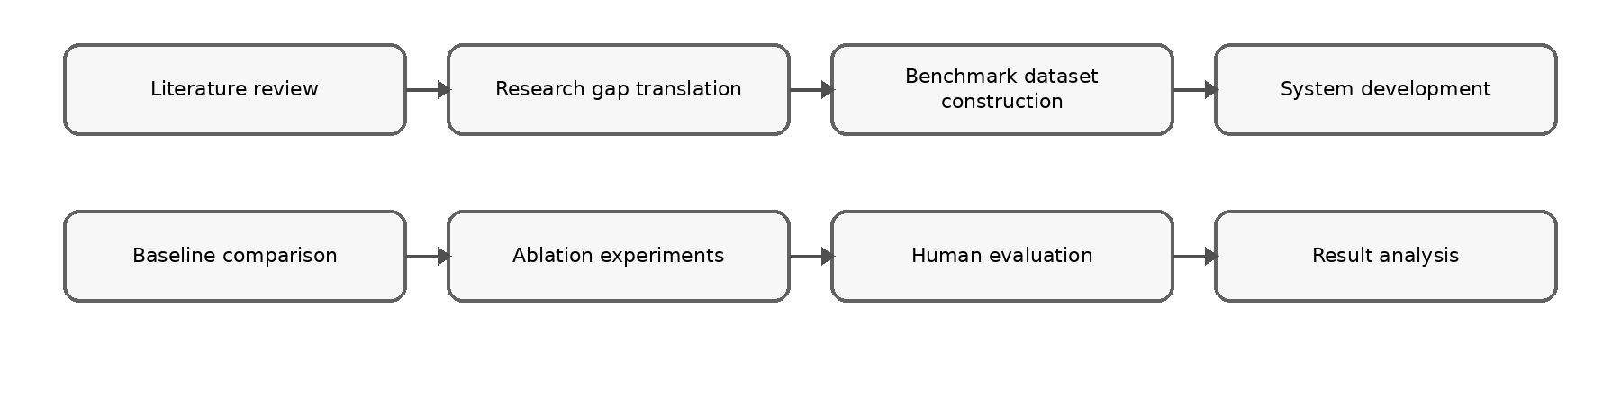Figure 3.1: Research Methodology Framework
Accordingly, this chapter defines the research design and workflow, research question and objective mapping, dataset and ground-truth preparation, preprocessing and leakage prevention, baseline selection, proposed AI method, experimental protocol, evaluation metrics, validation procedures, tools and reproducibility controls, and ethical, privacy, security and validity considerations.

Research Design and Workflow
This research adopts a design science research approach supported by quantitative experimentation and human-centred evaluation. Design science is appropriate because the main output of the study is an artefact: a decision-support system that addresses a practical and research problem through design, implementation, demonstration and evaluation (Peffers et al., 2007). The artefact is evaluated as an AI-assisted methodology for producing actionable, intent-consistent, logically constrained and trust-calibrated marketing recommendations.
The research approach is bounded and experiment-driven. The dataset, decision-case representation, business intent taxonomy, recommendation action space, baseline configurations, ablation variants and evaluation metrics are fixed before final testing. This reduces arbitrary post-hoc adjustment and improves reproducibility. Offline benchmark evaluation is used because the project does not claim production deployment or long-term business impact. Human-centred evaluation is included because recommendation usefulness depends not only on technical correctness but also on whether users can understand and appropriately rely on the generated recommendation.
The design also follows a modular method structure. Each AI module is defined by its motivation, input representation, forward process, output and evaluation role. This organisation makes the methodology easier to reproduce because another researcher can identify what each module receives, how the module transforms the input and which metric assesses its contribution. The system is therefore evaluated as a transparent decision-support pipeline rather than as a monolithic black-box application.
The proposed system is developed as a modular decision-support pipeline. The pipeline separates predictive-attribution analysis, candidate action generation, weighted soft-rule reasoning, intent-aware decision modelling, trust calibration and structured explanation generation. This modular design supports maintainability and directly supports ablation-first evaluation because individual modules can be removed or modified without rewriting the entire system.
The development sequence begins with data preparation because all later components depend on a consistent decision-case representation. Predictive and attribution outputs are then produced as evidence signals. These signals are not treated as final decisions. Candidate actions are generated and subsequently evaluated against rule-based constraints and business intent. Trust calibration and explanation generation are applied after the recommendation has been selected, so the final output includes both a recommended action and the information needed for human review.

The prototype remains a human-in-the-loop decision-support system. It recommends actions, reports confidence and explains reasoning, but it does not execute campaigns, modify advertising budgets or connect directly to live advertising platforms. This boundary preserves human accountability and keeps the project within a realistic software engineering scope. It also supports the ethical position that marketing decisions involving expenditure and risk should remain reviewable by a human manager.
Table 3.1 Research Methodology Framework
Phase | Research Activity | Methods / Techniques | Output
1 | Literature Review | Systematic review of marketing analytics, neuro-symbolic AI, trust calibration, explainable AI | Research gaps and design requirements
2 | Requirement Analysis | Problem analysis, framework synthesis, requirement elicitation | Functional and non-functional requirements
3 | Dataset Construction | Data collection, cleaning, preprocessing, feature engineering, decision case construction | Benchmark dataset with business intent labels
4 | System Development | Design Science Research, predictive-attribution model, weighted soft-rule reasoning | Proposed decision support system
5 | Ablation Experiments | Component removal experiments | Effect of each module on system performance
6 | Quantitative Evaluation | Accuracy, Scenario-Fit Rate, Conflict Rate, ECE, Latency | Performance evaluation
7 | Human Evaluation | Practitioner questionnaire, usefulness assessment, trust evaluation | User acceptance and trust analysis
8 | Result Analysis | Statistical comparison, baseline comparison, discussion | Findings and interpretation
9 | Conclusion | Summary, limitations, future work | Final conclusions

Dataset or Corpus
The dataset must provide enough variation for predictive modelling, attribution evidence and decision-case construction. The target configuration requires at least 500 campaign-period records, at least three marketing channels, a minimum observation period of six months and at least one measurable business outcome such as conversion, revenue, acquisition cost or return on investment. These conditions are selected to support meaningful evaluation of cross-channel marketing evidence and bounded recommendation generation.
If the dataset does not fully satisfy the target configuration, the experiment is reported as a simplified configuration and cross-channel conclusions are treated as exploratory. This fallback condition prevents the project from overclaiming beyond the available evidence. The system can still be evaluated as a decision-support pipeline, but conclusions about multi-channel interaction effects must be limited when the dataset contains fewer channels or insufficient observation periods.
The benchmark dataset is frozen before final evaluation. Freezing the benchmark means that the final test cases, intent labels, action labels and evaluation split are not changed after model tuning begins. This improves reliability because the system cannot be repeatedly adjusted to fit the final test cases. It also supports replication because the same cases can be reused for baselines, ablation variants and final comparison.
The primary data source is the Nykaa Marketing Campaign Performance Dataset from Kaggle. The dataset contains campaign-level attributes such as campaign type, target audience, marketing channel, impressions, clicks, leads, conversions, revenue, acquisition cost, ROI, engagement score, customer segment, language and campaign date. These attributes support both predictive evidence and decision-case reasoning because they capture performance, cost, channel and contextual factors.
The dataset is used as a structured academic benchmark rather than as a live business deployment dataset. The system does not require personally identifiable customer information, live customer tracking or direct social media account credentials. Only attributes required for modelling, rule evaluation, calibration, explanation and evaluation are retained. This design supports privacy-by-design and reduces unnecessary data exposure.
Derived features are constructed to support recommendation reasoning. Examples include click-through rate, conversion rate, cost per acquisition, revenue per conversion, ROI band, engagement band and channel saturation indicator. These features help translate raw campaign records into decision cases that can be interpreted by both predictive and symbolic components. Each derived feature is defined before final evaluation to avoid inconsistent interpretation during testing.
The target benchmark contains at least 500 campaign-period records covering at least three marketing channels and six months of observations. Its unit of analysis is the campaign-period record. Input fields cover campaign context, channel exposure, engagement, cost and outcome variables; derived fields include click-through rate, conversion rate, cost per acquisition, revenue per conversion, ROI band, engagement band and channel saturation. The controlled labels are the business-intent classes Survival, Retention and Growth and the recommendation classes Increase, Maintain, Reduce and Investigate. The final record count, class distribution and excluded records are reported after the reproducible data audit.

Data Collection and Sampling
Each cleaned campaign-period record is transformed into a structured decision case. A decision case contains campaign features, derived performance indicators, a business intent label and a benchmark recommendation label where available. The decision-case representation is necessary because the project is not only predicting a numerical outcome; it is recommending a bounded managerial response under a specified strategic condition.
The three business intent categories are Survival, Retention and Growth. Survival prioritises cost control, risk reduction and cash preservation. Retention prioritises repeat customers, customer value and relationship maintenance. Growth prioritises acquisition and expansion when expected returns justify greater spending. These categories are intentionally bounded so that the same evidence can be evaluated under controlled strategic scenarios.
The action space is limited to Increase, Maintain, Reduce and Investigate. Increase indicates that additional investment or expansion is supported. Maintain indicates that the current strategy remains acceptable. Reduce indicates that reduced allocation is justified due to weak performance, excessive cost or conflict with constraints. Investigate indicates that the evidence is uncertain, contradictory or insufficient for confident action. This fixed action set makes recommendation accuracy, scenario fit and actionability measurable across all configurations.
Records are included when the fields needed to compute the selected performance, cost and outcome indicators are available or can be handled by a predefined missing-value rule. Duplicated records, unusable records and cases whose labels remain unresolved after review are excluded. Sampling preserves representation across channel and intent classes; where usable dates exist, chronological ordering is retained for splitting. The Kaggle dataset is accessed only under the access conditions published with the source and is stored in the controlled project workspace. Because the benchmark uses secondary campaign-level data and excludes personally identifiable customer information, individual customer consent is not collected; any separate human evaluation follows participant information and voluntary-consent procedures.

Labelling and Annotation
Ground-truth recommendation and intent labels are prepared using documented definitions for the three intents and four actions. Label quality is checked through independent review where more than one annotator is available. Cohen's Kappa measures nominal agreement beyond chance, disagreements are discussed against the written labelling rules, and cases that cannot be resolved are removed before the benchmark is frozen.
The raw source is first evaluated against the source-audit requirements. A 20-to-30-case pilot is conducted before full annotation to refine the action rubric and remove ambiguous criteria.
Two reviewers independently assign business-intent and reference-action labels to all retained benchmark cases without viewing system recommendations. Cohen’s kappa is calculated for the nominal labels and must reach at least 0.60. Disagreements are referred to a third reviewer, and unresolved cases are removed before the benchmark is frozen.
The benchmark, partitions, action definitions, intent definitions, conflict rules, and evaluation procedures are locked before confirmatory model comparison begins.

Preprocessing

Figure 3.2 Data Preparation Workflow
The planned preprocessing methodology begins with an audit of the raw campaign records. Anticipated input problems include exact duplicate rows or reused campaign identifiers, inconsistent or unparseable dates, numeric values stored as text, missing performance measures, zero denominators in derived ratios, implausible extreme values and inconsistent categorical spellings. These conditions are treated as data-quality problems rather than model evidence. Figure 3.2 summarises the planned sequence from raw-record preservation to the frozen benchmark; the detailed partitioning protocol is specified separately in Section 3.3.
The planned sequence is to preserve an unchanged raw layer; verify the schema, identifier and date fields; remove exact duplicate rows; standardise and parse dates; order records chronologically; coerce designated measures to numeric form; establish the training, validation and test partitions; fit training-derived transformations; impute missing numerical values; construct zero-safe ratios; standardise model inputs; and validate the final feature structure. A mixed or unsupported date format will cause validation to fail instead of being silently interpreted. A numerical field with no usable training value will also fail the pipeline. For ratio features, zero denominators will use predefined non-fitted fallbacks so that division-by-zero values cannot propagate into the model.
Median imputation is planned because it is less sensitive than mean imputation to highly skewed marketing measures. General row deletion will not be used for outlier treatment because unusual campaigns may be operationally meaningful; instead, any model-target clipping boundary will be estimated from the training partition. The predictive path will use numerical campaign measures, the fixed business-intent vocabulary will be encoded only for the supervised action component, and channel information will be retained as a separate evidence signal rather than expanded into a high-dimensional campaign-category matrix. Python with pandas and NumPy is planned for validation and feature construction, while scikit-learn will provide feature standardisation. The expected output is an ordered, validated modelling frame containing the 13 numerical model features, together with the fitted preprocessing state and an evidence trace linking processed records to their source identifiers.
All transformations whose values are learned from data will be fitted using training records only. These include numerical imputation medians, standardisation means and standard deviations, model-target clipping quantiles, target-normalisation statistics and channel-normalisation statistics. Schema checks, date-format rules, identifier checks and zero-denominator formulas are deterministic rules and will be applied identically to all partitions. No statistic will be re-estimated using validation or test records. Section 3.3 defines the complete splitting order, validation boundary and test-set restrictions that enforce this control.

Data Splitting and Leakage Prevention
Before partitioning, the independently labelled decision benchmark will pass the annotation review described in Section 3.2.2. Reviewer agreement will be examined using Cohen's kappa for nominal intent and action labels, disagreements will be adjudicated, and unresolved cases may be excluded before the benchmark is frozen. Freezing the benchmark before model comparison prevents labels from being revised in response to model errors or experimental results.
The approved split is chronological 70:15:15. Records will first be ordered by campaign date and Campaign_ID. The earliest 70% will form the training partition, the next 15% the validation partition and the latest 15% the held-out test partition. The campaign source and the audited decision benchmark will be partitioned separately using the same proportions. Chronological splitting is preferred because it represents the intended deployment condition in which later campaigns are unavailable during training. A stratified fallback by intent and channel will be permitted only if usable dates are unavailable; the fallback decision must be documented before performance is inspected.
Only the training partition may fit preprocessing statistics, feature scalers, target clipping limits, target-normalisation values, predictive-model parameters, supervised action-model parameters and training-derived channel evidence. The validation partition may be used for model configuration, decision-threshold review and temperature calibration, but it must not update imputation or scaling statistics. Annotation, reference-action and adjudication fields are excluded from the campaign predictive frame so that target information cannot enter model features.
The held-out test partition will remain untouched until the final confirmatory comparison in Chapter 5. It will not be used for preprocessing refitting, model selection, threshold selection, rule-weight selection, calibration or explanation-template revision. Every comparable baseline and proposed-system condition will receive the same held-out cases, feature definitions, action vocabulary and metric implementation. Split membership, random seed, fitted configuration and data version will be recorded so that each result can be reconstructed without reopening the test set for further tuning.

Proposed Approach
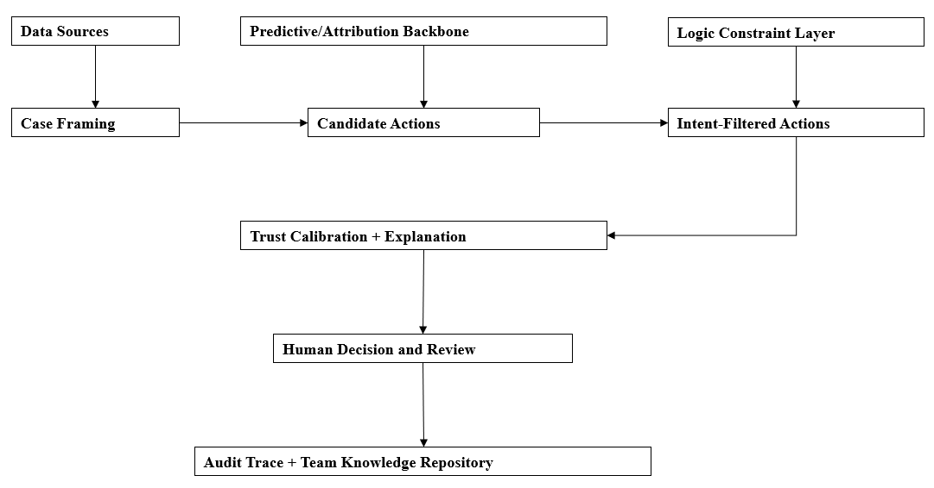
Figure 3.3: Implementation Pipeline for Decision Support System
Figure 3.3 shows the implementation pipeline. Marketing data are first cleaned and converted into decision cases. The predictive-attribution backbone then produces performance evidence and attribution signals. Candidate action generation converts evidence into bounded action alternatives. Weighted soft-rule reasoning evaluates feasibility and constraint satisfaction. Intent-aware ranking adjusts the recommendation for survival, retention or growth. Trust calibration and structured explanation then prepare the recommendation for human review.
The outputs of earlier stages become inputs to later stages. For example, the predictive-attribution backbone produces a performance score and evidence drivers, but it does not decide whether the campaign should be increased or reduced. Candidate action generation uses these signals to create possible actions. The soft-rule module then evaluates whether each action is feasible under cost, budget and channel constraints. The intent-aware module adjusts the ranking so that the same evidence can be interpreted differently under survival, retention and growth objectives.
The final recommendation package contains the selected action, calibrated confidence, activated reasoning evidence and structured explanation. This package supports auditability because a recommendation can be traced from the input case to predictive evidence, rule satisfaction, intent adjustment, confidence calibration and explanation. This trace also supports later testing in Chapter 5 because each stage produces measurable outputs.
Table 3.2: End-to-End Method Pipeline
Stage | Input | Processing | Output | Evaluation Link
Data preparation | Raw campaign records | Clean, validate, derive features and construct decision cases. | Frozen benchmark cases. | Dataset completeness and reproducibility.
Predictive-attribution backbone | Prepared decision cases | Estimate campaign outcome and attribution-related evidence. | Prediction score and evidence drivers. | Predictive and attribution baseline performance.
Candidate action generation | Prediction and attribution evidence | Generate Increase, Maintain, Reduce or Investigate alternatives. | Candidate action list. | Recommendation accuracy and actionability.
Weighted soft-rule reasoning | Candidate actions and rule base | Score budget, cost, risk, saturation and feasibility constraints. | Constraint-aware ranking. | Logical conflict rate.
Intent-aware decision module | Action ranking and intent label | Adjust priorities for Survival, Retention or Growth. | Intent-consistent recommendation. | Scenario-fit rate.
Trust and explanation layer | Final recommendation and evidence trace | Calibrate confidence and generate driver, implication, action and caveat. | Recommendation package for human review. | ECE, trust alignment and explanation usefulness.
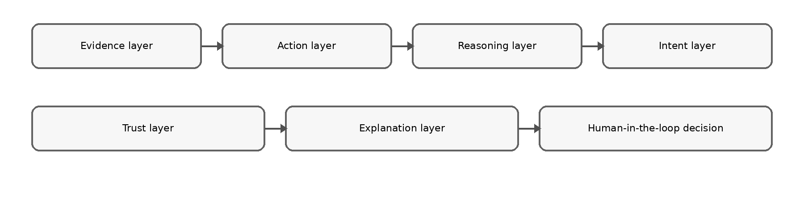

Figure 3.4: AI Component Architecture
The AI methodology is organised using a consistent module structure: motivation, module design and technical advantage. This makes the method easier to understand and evaluate because each component explains why it is needed, how it operates and which metric should show its contribution. Figure 3.4 summarises the main AI component architecture.

Predictive-Attribution Backbone
The predictive-attribution backbone supplies campaign evidence before symbolic reasoning begins. A purely rule-based system may be transparent, but it may ignore learned relationships between campaign exposure, engagement, cost and revenue. A predictive model can estimate likely performance, while attribution-related evidence identifies which channel or campaign factors contribute to the predicted outcome. The backbone therefore provides an empirical evidence layer for later recommendation reasoning.
Given a prepared decision case, the module extracts channel exposure, engagement, conversion, revenue and cost features. It estimates a campaign performance signal and derives attribution-related evidence indicating influential channels or campaign factors. The output contains a prediction score, evidence drivers and confidence-related signals. These outputs are passed to candidate action generation and later reused by the explanation module.
The technical advantage of this separation is evaluability. The predictive-attribution backbone can be compared with the full framework to determine whether the reasoning, intent and trust layers add value beyond evidence generation. If the full framework improves actionability, scenario fit or conflict rate over the backbone-only configuration, the results support the need for integrated decision reasoning rather than prediction alone.

Candidate Action Generation
Candidate action generation addresses the attribution-to-action gap by converting analytical evidence into a bounded set of possible managerial actions. Prediction and attribution may indicate that a campaign performs well or poorly, but managers require a decision option such as increasing investment, maintaining the current strategy, decreasing allocation or investigating uncertain results. This module creates those action alternatives before rule and intent evaluation.
The module receives prediction scores, attribution drivers and derived performance indicators. It then generates eligible actions from the four-action set: Increase, Maintain, Reduce and Investigate. Strong performance and acceptable cost may make Increase eligible. Stable moderate performance may support Maintain. Weak performance or excessive acquisition cost may support Reduce. Conflicting evidence or low confidence may support Investigate. Multiple candidates can be generated, allowing the reasoning layer to rank alternatives instead of forcing an immediate decision.
The main advantage of a bounded action generator is consistent evaluation. All baselines and ablation variants use the same action labels, so recommendation accuracy, actionability and scenario-fit rate can be compared directly. The fixed action set also strengthens auditability because each recommendation category has a clear managerial interpretation.

Weighted Soft-Rule Reasoning
Weighted soft-rule reasoning tests whether candidate actions are feasible under SME business constraints. Prediction alone may recommend expansion for a campaign with strong conversion potential, but the same action may be unsuitable if acquisition cost is excessive, budget is limited, margin is weak or the channel appears saturated. Symbolic rules make these constraints explicit and reviewable.
The module evaluates each candidate action against predefined rule categories. Budget feasibility checks whether the action can be supported by available resources. Cost efficiency checks acquisition cost and return. Channel saturation checks whether increasing investment may produce diminishing returns. Risk rules penalise aggressive actions under uncertain evidence. Intent compatibility rules adjust the suitability of an action under Survival, Retention or Growth. Each rule returns a satisfaction score, and the final action score is computed through weighted aggregation.
Soft rules are used instead of strict hard rules because SME marketing decisions often involve partial trade-offs. A campaign may slightly exceed a preferred cost threshold but still be reasonable under a growth strategy if revenue potential is high. Conversely, a campaign may satisfy a performance threshold but remain unsuitable under a survival strategy. Weighted satisfaction therefore supports flexible reasoning while preserving transparency.
This module is evaluated mainly through logical conflict rate and actionability. A conflict occurs when the selected recommendation violates an important predefined constraint. If removing the soft-rule module increases conflict rate, the results support the contribution of explicit constraint-aware reasoning.

Intent-Aware Decision Module
The intent-aware decision module adjusts action ranking according to the selected strategic context. The same campaign evidence can justify different actions depending on whether the business is trying to survive, retain customers or grow. Without intent awareness, the system may optimise a generic performance target while producing recommendations that are misaligned with the current business objective.
Under Survival, the module places higher weight on cost control, risk reduction, margin protection and cash preservation. Under Retention, the module places greater emphasis on repeat-customer value, engagement quality and relationship-oriented indicators. Under Growth, the module gives greater weight to acquisition potential, conversion momentum and scalable channel performance, provided that rule violations remain controlled. The output is an intent-adjusted ranked list of candidate actions.
The main evaluation metric for this component is scenario-fit rate. Scenario-fit measures whether the selected action is compatible with the assigned strategic intent. If the no-intent ablation performs worse on scenario-fit, the result supports the claim that intent conditioning improves contextual relevance.

Trust Calibration Module
Trust calibration aligns confidence scores with observed recommendation reliability. Calibration is required because predictive models may produce overconfident or underconfident probabilities, and poorly calibrated confidence can encourage inappropriate reliance. A high confidence score should correspond to a higher likelihood of correctness, while a low confidence score should encourage additional checking.
The module applies temperature scaling as a post-processing calibration method. Temperature scaling adjusts predicted probabilities using a validation set without changing the ranking order of recommendations. Expected Calibration Error is then computed by grouping predictions into confidence bins and comparing average confidence with observed correctness in each bin (Guo et al., 2017). Lower ECE indicates better alignment between confidence and actual reliability.
The output of this module is a calibrated confidence score and a confidence category. High-confidence recommendations can support faster review, medium-confidence recommendations require normal review and low-confidence recommendations should trigger caution or investigation. The module is evaluated through ECE, overtrust rate and trust alignment. Removing this component should mainly affect confidence reliability rather than the action label itself.

Structured Explanation Generation

Figure 3.5 System Component Architecture
The explanation module generates a fixed explanation package consisting of Driver, Implication, Action and Caveat. The Driver states the main evidence behind the recommendation. The Implication translates the evidence into business meaning. The Action states the suggested response. The Caveat communicates uncertainty, risk or assumptions. This format is suitable for SME decision support because it avoids purely technical explanations while still preserving auditability.
Given the final recommendation, the module extracts the strongest evidence drivers, activated rules, selected intent and calibrated confidence. It then produces a concise explanation that links data evidence to the suggested action. For example, a recommendation to reduce investment may be explained by high acquisition cost, weak conversion and a survival intent. A recommendation to investigate may be explained by inconsistent evidence or low confidence.
The explanation module is evaluated through explanation usefulness and trust alignment. The goal is not to make users accept every recommendation. The goal is to help users understand why a recommendation was produced and how much caution is required before acting. This supports appropriate reliance and human accountability.

Baseline Selection and Justification
The proposed system integrates predictive modelling, attribution evidence, weighted soft-rule reasoning, business-intent conditioning, trust calibration, and structured explanations. Evaluating only the complete system would not reveal which components are responsible for any observed improvement. Therefore, the experimental design compares the proposed system with theory-driven baselines and controlled ablation variants representing partial solutions to the attribution-to-action problem.
All systems receive the same prepared decision cases, use the same four-action output space of Increase, Maintain, Reduce, and Investigate, and are evaluated using identical frozen test cases. Model parameters, decision thresholds, rule weights, and calibration parameters are selected using only the training or validation partitions. No system is permitted to access test labels or additional test-set information during development.
The comparisons are organised according to the five experiment blocks described in Section 3.9.

Block 1 Baselines: Decision Recommendation Performance
Block 1 evaluates whether the integrated predictive-attribution backbone produces more useful decision recommendations than simpler analytical approaches.
The following systems are compared:
- Heuristic scorecard baseline. This baseline uses manually specified thresholds for indicators such as return on investment, conversion rate, acquisition cost, and engagement. It represents a transparent but relatively inflexible form of managerial decision support. Its expected limitation is that manually selected thresholds may not capture learned relationships among heterogeneous campaign characteristics.
- Predictive-only baseline. This baseline uses the output of the predictive model to select an action without attribution evidence, business-intent conditioning, symbolic constraints, or confidence calibration. It tests whether prediction alone is sufficient to generate useful managerial recommendations. Its expected limitation is that an analytically favourable action may be unsuitable under the organisation’s budget, risk, or strategic conditions.
- Attribution-only baseline. This baseline derives an action from the estimated contribution of campaign or channel features without the complete recommendation-reasoning pipeline. It tests whether attribution evidence can directly support action selection. Its expected limitation is that high contribution does not necessarily justify additional investment when acquisition cost, channel saturation, or business intent is considered.
- Integrated backbone without logic or calibration. This configuration combines predictive evidence, attribution evidence, and bounded candidate-action generation but excludes weighted soft-rule reasoning, business-intent rules, and confidence calibration. It tests whether integrating prediction and attribution improves recommendation performance before the proposed logic and trust layers are introduced.
These baselines isolate whether improvements originate from predictive modelling, attribution evidence, or the initial attribution-to-action bridge.

Block 2 Baselines: Trust Calibration and Explanation
Block 2 evaluates whether calibrated confidence and structured explanations improve appropriate reliance rather than merely making recommendations appear more persuasive.
The following variants are compared:
- Uncalibrated recommendation with raw explanation text.
- Calibrated confidence without a structured explanation template.
- Structured explanation template without confidence calibration.
- Calibrated confidence combined with a structured explanation template.
The raw explanation condition acts as a control for the possibility that participants respond positively simply because explanatory text is present. The structured explanation condition uses a fixed driver–effect–action format, while the complete condition adds a confidence caveat. Comparing these variants distinguishes the effect of calibration from the effect of explanation wording.

Block 3 Baselines: Logic-Constrained Consistency
Block 3 evaluates whether integrated weighted soft-rule reasoning reduces logically inconsistent recommendations.
The following systems are compared:
- Integrated backbone without a logic layer. Candidate actions are selected from predictive and attribution evidence without applying business constraints.
- Post-hoc hard-rule filter. The initial action is selected first, after which fixed rules reject or replace actions that violate declared constraints.
- Weighted soft-rule layer. Business constraints contribute weighted satisfaction or penalty values during candidate-action scoring, allowing the system to balance partially competing considerations before selecting the final recommendation.
The post-hoc filter is an important control because it tests whether the benefits of the proposed system could be obtained through simple late-stage rule filtering. The weighted soft-rule method differs by incorporating rule satisfaction directly into action ranking instead of applying rules only after an action has already been selected.

Block 4 Baselines: Business-Intent Conditioning
Block 4 evaluates whether explicitly representing Survival, Retention, and Growth produces recommendations that better fit the declared business scenario.
The following policies are compared:
- Global policy. The shared predictive-attribution backbone generates recommendations without receiving business-intent inputs or applying intent-specific rules.
- Intent-conditioned policy without calibration. The same backbone receives the declared intent and applies intent-specific soft rules, but confidence calibration is disabled.
- Full proposed system. The predictive-attribution backbone, weighted soft-rule reasoning, business-intent conditioning, calibrated confidence, and structured explanation are enabled.
Using the same backbone across these configurations controls for predictive performance and allows differences in scenario fit to be attributed more directly to intent conditioning.

Block 5 Explanation Controls
Block 5 compares three explanation formats:
- Terse feature list.
- Driver–effect–action explanation.
- Driver–effect–action explanation with a confidence caveat.
This supporting experiment determines whether explanation format materially changes perceived clarity, usefulness, willingness to act, and willingness to review a recommendation before acting. It is treated as a design-refinement study rather than the main scientific contribution.
Table 3.3 summarises the five comparison blocks used to isolate the contributions of the predictive-attribution backbone, calibration and explanation structure, constraint reasoning, business-intent conditioning and explanation-template design. The source audit, annotation pilot and benchmark-freezing procedure are not treated as a comparison block because they form the preparatory gate that must be completed before the experimental comparisons begin. Therefore, Table 3.5 contains six runs: one preparatory run followed by five experimental comparison runs.
Table 3.3: Summary of Baseline and Ablation Systems
Experiment block | Compared systems | Main component isolated
Block 1 | Heuristic scorecard; predictive-only; attribution-only; integrated backbone without logic or calibration | Predictive-attribution backbone and attribution-to-action bridge
Block 2 | Raw explanation; calibrated confidence only; structured explanation only; calibrated confidence with structured explanation | Calibration and explanation structure
Block 3 | No logic layer; post-hoc hard-rule filter; weighted soft-rule layer | Integrated constraint reasoning
Block 4 | Global policy; intent-conditioned policy without calibration; full proposed system | Business-intent conditioning
Block 5 | Terse feature list; driver–effect–action explanation; driver–effect–action explanation with confidence caveat | Explanation-template design

Evaluation Metrics and Acceptance Criteria
The evaluation combines recommendation-performance, logical-consistency, calibration, human-reliance, explanation, and operational metrics. This combination is necessary because the proposed artefact is a decision-support system rather than only a predictive model.

Recommendation-Performance Metrics
Macro F1 calculates the F1 score independently for each of the four action classes and then averages the class-level scores. It is used because class frequencies may be unequal and overall accuracy could conceal poor performance on less frequent actions.
Top-2 agreement is the proportion of decision cases for which the audited reference action appears among the two highest-ranked actions produced by the evaluated system.
Actionability score is the mean of participant ratings for usefulness, specificity, and feasibility. Each item is measured on a five-point scale, and higher values indicate that the recommendation is easier to understand and apply.

Scenario and Logical-Consistency Metrics
Scenario-fit rate is the proportion of recommendations judged compatible with the declared Survival, Retention, or Growth intent.
Conflict rate is the proportion of recommendations that violate at least one predefined budget, channel-cap, or intent-compatibility rule. A recommendation with several simultaneous violations counts as one conflicting case in the overall rate, while the individual violation types are recorded separately.
Recommendation reversal rate is the proportion of cases for which the selected action changes after the constraint mechanism is applied. This metric shows how frequently the reasoning layer alters the initial evidence-based recommendation.

Calibration and Reliance Metrics
Expected Calibration Error measures the discrepancy between predicted confidence and empirical recommendation correctness across the five predefined confidence bins. Lower values indicate better agreement between confidence and observed correctness.
Trust alignment gap is the mean absolute difference between normalised willingness to act and empirical correctness within each reliability bin. Lower values indicate that participant reliance is more closely aligned with actual system reliability.
Overtrust rate is the proportion of recommendations with confidence below 0.60 for which participants select “Act immediately.” Lower values indicate less inappropriate reliance on low-confidence recommendations.
Willingness to act records the extent to which a participant is willing to follow the recommendation. It is interpreted together with correctness and confidence rather than being treated as a standalone indication of system quality.

Explanation Metrics
Explanation usefulness measures whether the explanation helps the participant understand and review the recommendation.
Perceived clarity measures whether the explanation communicates its evidence and intended action in an understandable manner.
Willingness to review before acting measures whether the explanation and confidence information encourage participants to perform an appropriate level of verification before accepting the recommendation.

Operational Metrics
Operational latency is measured from submission of a decision case until the complete recommendation package is returned. Both p50 and p95 latency are reported.
Decision time is the elapsed time between presentation of the recommendation and submission of the participant’s evaluation or decision.
Results are reported with 95% bootstrap confidence intervals. Model training is conducted using three predefined random seeds, with the same seed set applied to every comparable configuration. Holm correction is applied to repeated pairwise comparisons to control the family-wise error rate. Statistical significance is interpreted together with effect size and practical importance.
Table 3.4 Metrics and Acceptance Criteria
Metric | Interpretation | Acceptance criterion
Macro F1 | Balanced agreement with the four audited action classes | At least 0.60 and at least 0.05 above the heuristic baseline for confirmatory downstream claims
Top-2 agreement | Audited action appears in the two highest-ranked actions | Integrated backbone should match or outperform partial baselines
Actionability score | Mean usefulness, specificity, and feasibility rating | Full system should outperform the corresponding partial or ablated configuration
Scenario-fit rate | Compatibility with declared business intent | Intent-conditioned configurations should outperform the global policy
Conflict rate | Violation of budget, channel-cap, or intent rule | Weighted soft rules should reduce conflicts relative to no-logic and post-hoc controls
Recommendation reversal rate | Action changes after constraints are applied | Reported together with conflict reduction and actionability
Expected Calibration Error | Difference between confidence and empirical correctness | Calibrated condition should have lower ECE than the uncalibrated condition
Trust alignment gap | Difference between reliance and actual correctness | Calibrated structured-explanation condition should reduce the gap
Overtrust rate | Low-confidence recommendations marked “Act immediately” | Calibrated structured-explanation condition should reduce overtrust
Explanation usefulness | Helpfulness of explanation for review | Structured templates should outperform raw or terse explanations
p50 latency | Typical system response time | Reported for all principal configurations
p95 latency | High-percentile system response time | Below two seconds in Block 2; rule layer should not add more than 20% without reducing conflict
Decision time | Time required for participant judgement | Compared across intent and explanation conditions

Testing, Validation and Statistical Plan
Testing and validation consist of benchmark validation, model validation, logic validation, calibration validation, human evaluation, software verification, and reproducibility checks.

Benchmark and Annotation Validation
The raw source is first evaluated against the source-audit requirements. A 20-to-30-case pilot is conducted before full annotation to refine the action rubric and remove ambiguous criteria.
Two reviewers independently assign business-intent and reference-action labels to all retained benchmark cases without viewing system recommendations. Cohen’s kappa is calculated for the nominal labels and must reach at least 0.60. Disagreements are referred to a third reviewer, and unresolved cases are removed before the benchmark is frozen.
The benchmark, partitions, action definitions, intent definitions, conflict rules, and evaluation procedures are locked before confirmatory model comparison begins.

Model and Data Validation
Training, validation, and test partitions are separated by time or business unit where possible to minimise leakage. Preprocessing parameters are learned only from the training partition. Model hyperparameters, decision thresholds, rule weights, and temperature-scaling parameters are selected using only the validation partition.
The test partition is used once for final confirmatory comparison. The same test cases, features, action labels, computational environment, and metric implementations are used for every comparable configuration.

Logic and Conflict Validation
The business-rule implementation is tested using controlled cases representing valid and invalid combinations of budget, channel capacity, evidence strength, and business intent.
For every generated recommendation, the system records whether a conflict occurred and which rule categories were violated. Multiple violations are retained in the audit log even though the case contributes only one conflict to the overall conflict-rate calculation.
Representative rule activations, learned or selected rule weights, firing frequencies, and action changes are manually inspected to verify that the reasoning behaviour remains consistent with the declared domain logic.

Calibration Validation
Temperature scaling is fitted only on the validation partition. The calibration method is never fitted using test outcomes.
Expected Calibration Error is calculated using the five predefined confidence bins. Reliability results are compared between calibrated and uncalibrated conditions. Confidence is not described as calibrated until the benchmark has passed the independent annotation and adjudication gate.

Human Evaluation Protocol
The human evaluation targets between 18 and 24 participants. At least eight participants should be SME owners, marketing practitioners, campaign executives, or individuals with directly relevant marketing decision experience.
Practitioner recruitment proceeds through supervisor-approved SME contacts, university entrepreneurship or industry-outreach channels, and alumni marketing networks. If fewer than eight practitioners participate, the findings are reported as a bounded formative evaluation and are not generalised to the broader SME population.
Participants receive an information sheet explaining the research purpose, study procedure, expected duration, data collected, confidentiality protections, and their right to withdraw. Participation is voluntary, and informed consent is obtained before any study response is recorded. Personally, identifying information is not included in the reported findings.
System variants are presented using neutral condition identifiers so participants are unaware of which condition is the proposed system. Case order is counterbalanced to reduce learning, fatigue, and ordering effects. Explanation-template comparisons are conducted within-subject where feasible so that the same participant evaluates multiple formats under comparable conditions.
Participants review the campaign context, declared business intent, recommended action, displayed confidence, and explanation. They then rate usefulness, specificity, feasibility, clarity, and willingness to act using five-point response scales. They also indicate whether they would act immediately, review further, modify the recommendation, or reject it.
The time required to submit each judgement is recorded. Low-confidence recommendations are defined as recommendations with confidence below 0.60. Selecting “Act immediately” for such a recommendation contributes to the overtrust-rate calculation.

Software and Reproducibility Testing
Functional tests verify campaign input, preprocessing, prediction, attribution evidence, candidate generation, rule scoring, intent selection, calibration, explanation generation, and recommendation logging.
Integration tests verify that the complete recommendation package is transferred correctly between the backend, database, and user interface. Performance tests record p50 and p95 latency. Security and privacy tests verify access control, data minimisation, and exclusion of unnecessary personally identifiable information.
Each principal model experiment is executed using three predefined random seeds. Experiment identifiers, software versions, dataset version, partition identifiers, configuration parameters, outputs, and errors are recorded automatically.
Each run produces the following reproducibility artefacts:
- results/<run_id>.json
- logs/<run_id>.log
- refine-logs/EXPERIMENT_RESULTS.md

Experimental Setup
The evaluation is organised into five experiment blocks. Each block tests a specific research claim using the same frozen decision-case benchmark where applicable. This design prevents the evaluation from depending on a single overall performance value and makes the contribution of each system component observable.
Before confirmatory evaluation begins, the source dataset, decision cases, annotation rubric, intent definitions, action labels, conflict rules, data partitions, calibration procedure, and primary metrics are frozen. The final test partition is not used for model selection, rule-weight selection, or calibration.

Block 1: Source Audit and Baseline Decision Benchmark
Block 1 establishes whether the available data and audited decision cases are sufficient for the planned evaluation. It also tests whether the integrated predictive-attribution backbone improves action recommendation over partial analytical baselines.
The source-audit gate requires at least 500 campaign-period records, at least three marketing channels, at least six monthly periods, and at least one downstream business outcome. If the source does not satisfy these requirements, the project is reduced to a two-channel configuration and any cross-channel synergy claim is treated as exploratory.
A frozen benchmark of between 120 and 150 decision cases is constructed from the source data. Each case is assigned one reference action from Increase, Maintain, Reduce, and Investigate. Reference actions are produced through a supervisor-reviewed annotation rubric and relevant historical campaign context.
Before full annotation, a pilot inter-rater study is conducted using between 20 and 30 cases. Two reviewers then independently label all benchmark cases. Cohen’s kappa must be at least 0.60 before the benchmark can be frozen. Disagreements are submitted to a third reviewer, and cases that remain unresolved are excluded.
The compared systems are the heuristic scorecard, predictive-only baseline, attribution-only baseline, and integrated backbone without logic or calibration.
The primary metrics are macro F1, top-2 agreement, actionability score on a held-out subset, and p50 response latency. The integrated backbone must at least match or outperform the partial baselines while maintaining interactive response time. If macro F1 is below 0.60 or fails to improve upon the heuristic baseline by at least 0.05, subsequent logic and trust-calibration findings are presented as exploratory rather than confirmatory.

Block 2: Trust Calibration and Appropriate Reliance
Block 2 tests whether calibrated confidence and structured explanations support appropriate reliance.
Temperature scaling is fitted using only the validation partition. Confidence values are grouped into the following five predefined bins:
- [0.0, 0.2)
- [0.2, 0.4)
- [0.4, 0.6)
- [0.6, 0.8)
- [0.8, 1.0]
The compared conditions are an uncalibrated recommendation with raw explanation text, calibrated confidence only, a structured explanation without calibration, and calibrated confidence combined with a structured explanation.
The primary metrics are Expected Calibration Error, trust alignment gap, overtrust rate, explanation usefulness, and p95 response latency. The complete calibrated-template condition should reduce the trust alignment gap and overtrust rate relative to the uncalibrated conditions. Its p95 response latency must remain below two seconds per decision case.
If calibration does not reduce the trust alignment gap or overtrust rate, the negative result is reported. In this case, the system may retain explanation support but must not claim that calibrated confidence improves appropriate reliance.

Block 3: Logic-Constrained Attribution-to-Action Consistency
Block 3 tests whether weighted soft rules reduce logically inconsistent recommendations.
A recommendation is classified as conflicted when it violates at least one predefined budget, channel-cap, or intent-compatibility rule. Multiple violations within the same case count as one conflicting recommendation when calculating the conflict rate, although each violation type is recorded separately for diagnostic analysis.
The compared systems are the integrated backbone without logic, the post-hoc hard-rule filter, and the weighted soft-rule layer tuned using only the validation partition.
The primary metrics are conflict rate, scenario-fit rate, actionability score, and recommendation reversal rate after constraint application. Learned rule weights, rule-firing rates, and representative test-set activations are also reported.
The weighted soft-rule layer should reduce conflict rate by a practically meaningful margin without causing a substantial reduction in actionability. If the learned rule-weight profile is inconsistent with the intended domain logic, the claim concerning logic-constrained reasoning is reduced accordingly. If the rule layer increases p95 latency by more than 20% without reducing conflict rate, it is simplified or removed from the final claimed contribution.

Block 4: Intent-Conditioned Recommendation Study
Block 4 evaluates whether business-intent conditioning improves contextual relevance.
The evaluation uses a held-out scenario set balanced across Survival, Retention, and Growth cases. The global and intent-conditioned configurations use the same predictive-attribution backbone so that differences are not caused by changes to the predictive model.
The compared systems are a global policy without intent inputs, an intent-conditioned policy without calibration, and the full proposed system.
The primary metrics are scenario-fit rate, actionability score, willingness to act, and decision time. The full system should demonstrate clearer differences among the three intent scenarios and higher judged usefulness than the global policy.

Block 5: Explanation Template Variant
Block 5 is a supporting experiment used to select the final dashboard explanation format.
The compared formats are a terse feature list, a driver–effect–action template, and a driver–effect–action template with a confidence caveat.
The metrics are explanation usefulness, perceived clarity, willingness to act, and willingness to review before acting. A template is selected for the final interface only if it demonstrates a sufficiently clear and consistent advantage. Otherwise, the simplest comprehensible template is retained.

Run Order and Decision Gates
The experiments are executed in the following order in Table 3.5:
Table 3.5 Run Order and Decision Gates
Run | Experiment | Decision gate
R001 | Source audit, rubric pilot, annotation agreement, and benchmark freeze | Does the source satisfy the audit gate, and is Cohen’s kappa at least 0.60?
R002 | Baseline decision-performance comparison | Does the integrated backbone reach macro F1 of at least 0.60 and improve upon the heuristic baseline by at least 0.05?
R003 | Calibration and appropriate-reliance study | Does calibration reduce trust misalignment and overtrust while keeping p95 latency below two seconds?
R004 | Logic-constrained consistency experiment | Do weighted soft rules reduce conflicts without unacceptable actionability or latency loss?
R005 | Intent-conditioning experiment | Does intent conditioning improve scenario fit and judged usefulness?
R006 | Explanation-template experiment | Is one explanation format sufficiently better to justify adoption in the final interface?

If fewer than 120 audited cases remain after annotation and adjudication, the evaluation is reported as a formative decision-support case study. If fewer than eight SME or marketing practitioners participate, human-study findings are also treated as formative and are not generalised to the wider SME population.

Software, Hardware and Versions
The experimental environment uses the software, libraries, versions and hardware summarised in Tables 3.6 and 3.7. These details are recorded to support consistent reproduction of the model, baseline and ablation experiments. Full application architecture and implementation details are presented in Chapter 4.
Table 3.6 Development Environment
Category | Technology | Purpose
Frontend Framework | React | Interactive user interface
Build Tool | Vite | Fast frontend development and production build
Programming Language | TypeScript | Type-safe frontend development
Backend Framework | FastAPI | RESTful API and AI service integration
Programming Language | Python | AI implementation and backend logic
Database | MySQL | Persistent storage of campaigns, recommendations, and evaluations
ORM | SQLAlchemy | Database access and object-relational mapping
Deep Learning Framework | PyTorch | Neural predictive model implementation
Data Processing | pandas | Data cleaning, preprocessing, and feature engineering
Machine Learning Utilities | scikit-learn | Dataset splitting, preprocessing, baseline models, and evaluation metrics
Version Control | GitHub | Source code management
IDE | Visual Studio Code | Software development
Operating System | Windows 11 | Development environment
Hardware | Intel Core i5 Processor, 24 GB RAM | Experimental platform

Software Versions
To ensure consistency and reproducibility, all software components were maintained using fixed versions throughout development and experimentation.
Table 3.7 Software Versions
Software | Version
Python | 3.11.9
React | 19.x
Vite | 7.x
TypeScript | 5.x
FastAPI | 0.115.x
SQLAlchemy | 2.x
MySQL | 8.x
PyTorch | 2.7.x
pandas | 2.x
scikit-learn | 1.7.x
Git | 2.x
Visual Studio Code | Version recorded in the project environment capture
Windows | Windows 11

The project adopts standard dependency management practices to ensure that all development environments remain consistent.
Frontend dependencies are managed using npm, while backend Python packages are managed using pip and recorded in a requirements.txt file. This enables the complete software environment to be recreated on another machine using the same package versions.
Version control is maintained using GitHub, where source code revisions are tracked throughout the development lifecycle.

Ethics, Privacy and Reproducibility

Ethical Considerations
The proposed system functions strictly as a decision-support tool. It generates recommendations, confidence scores and explanations for human review, but it does not execute campaigns automatically. Final marketing decisions remain with the SME manager. This boundary is important because marketing recommendations may influence expenditure, risk and business accountability.

Privacy and Data Governance
The project applies data minimisation. Only attributes required for modelling, rule evaluation, calibration, explanation and evaluation are retained. Personally identifiable customer information is excluded. Benchmark results are reported in aggregate form. These practices are consistent with the privacy principles of Malaysia’s Personal Data Protection Act 2010, including purpose limitation and protection of personal data.

Experimental Reliability and Reproducibility
Reliability is supported through benchmark freezing, fixed random seeds, documented preprocessing steps, version control and recorded experimental configurations. The same test cases are used across all baselines and ablation variants. Rule definitions, intent labels, action labels and metric formulas are fixed before final evaluation so that results can be reproduced and compared fairly.

Study Limitations and Validity
The study is bounded to a prototype-level evaluation. The dataset may not represent every SME industry or campaign context. The action space is limited to Increase, Maintain, Reduce and Investigate, while the intent taxonomy is limited to Survival, Retention and Growth. These boundaries improve experimental control but limit generalisation. The evaluation is offline and benchmark-based, so the study cannot claim long-term business impact without future live deployment.
Internal validity is protected through a frozen test set, identical comparison cases and component-removal experiments, although benchmark labelling and rule definitions may still introduce judgement bias. Construct validity is supported by mapping each objective to explicit technical and human-centred metrics, while recognising that bounded actionability and scenario-fit measures cannot represent every managerial judgement. External validity is limited by the use of one secondary benchmark and three simplified SME intents. Conclusion validity is supported by confidence intervals, multiple-comparison correction and practical-significance interpretation, but findings remain subject to benchmark size and participant coverage.

Reproducibility and Data Availability
Several measures were implemented to improve the reproducibility of the experimental results.
First, the benchmark dataset was frozen before model training. Once the training, validation, and testing datasets were established, they remained unchanged throughout all experiments, ensuring that every baseline, ablation study, and proposed model was evaluated using identical data.
Second, deterministic random seeds were applied during model training and dataset splitting to minimise variations caused by random initialisation and sampling.
Third, all source code was maintained using GitHub version control. Every implementation change was recorded through commit history, enabling previous experimental configurations to be recovered if necessary.
Furthermore, evaluation metrics, prediction outputs, and experimental configurations were logged automatically after each experiment. This facilitates fair comparison among baseline models, ablation studies, and the proposed neuro-symbolic framework.
Finally, business intent definitions, recommendation rules, benchmark datasets, and evaluation procedures were fixed before experimentation to prevent post-hoc modification of the evaluation process.

Reproducibility Measures
Table 3.8 Reproducibility Measures
Aspect | Measure
Dataset | Frozen benchmark dataset
Dataset Split | Fixed training, validation, and testing partitions
Randomness | Fixed random seeds for dataset splitting and PyTorch model training
Software | Fixed package versions
Source Code | GitHub version control
Dependencies | npm and pip package management
Evaluation | Standardised metrics and benchmark procedures
Logging | Prediction results and experiment configurations recorded

Objective–Method–Evidence Mapping
Each research objective and research question is connected to a method, evidence source and measurable acceptance criterion. This traceability prevents the evaluation from depending on broad claims such as system usefulness or recommendation intelligence. Instead, each major claim must be supported by a dataset, baseline, metric, ablation variant or human-centred assessment.
The mapping is especially important because the research questions assess different qualities of the system. RQ1 focuses on whether predictive and attribution evidence can be converted into actionable recommendations. RQ2 focuses on confidence calibration and appropriate reliance. RQ3 focuses on intent-aware contextual fit across survival, retention and growth scenarios. RQ4 focuses on feasibility, auditability and prototype-level implementation constraints. The evaluation design therefore uses multiple metrics rather than treating prediction accuracy as the only indicator of success.
Table 3.9 summarises the relationship between the research objectives, research questions, implementation methods, experimental procedures, and evaluation metrics adopted throughout this study.
Table 3.9: Mapping of Research Objectives, Research Questions and Evaluation
Research Objective | Research Question | Method / System Component | Evaluation Evidence | Acceptance Criterion
RO1: Construct an anonymised benchmark dataset consisting of SME multi-channel marketing decision cases with predefined business intent scenarios. | RQ4 | Data audit, preprocessing, feature derivation, intent assignment, action labelling and benchmark freezing. | Dataset completeness, feature coverage, missing-value report, label review and reproducible split. | The dataset is sufficient for the selected experimental configuration and remains fixed before final evaluation.
RO2: Implement a predictive-attribution backbone integrated with weighted soft-rule recommendation reasoning. | RQ1 | Predictive evidence, attribution signals, bounded candidate actions and weighted rule scoring. | Baseline comparison against heuristic, predictive-only, attribution-only and post-hoc rule overlay systems. | The full framework improves actionability and reduces logical conflict compared with relevant partial baselines.
RO3: Develop a trust calibration and structured explanation module for AI-assisted recommendations. | RQ2 | Temperature scaling, confidence bins, Expected Calibration Error and driver-implication-action-caveat explanations. | Calibration analysis, overtrust rate, trust alignment and explanation-usefulness feedback. | The calibrated version reports lower calibration error and clearer reliance guidance than the uncalibrated variant.
RO4: Evaluate the proposed decision support system against existing baseline approaches. | RQ1–RQ4 | Controlled comparison across full framework, baselines and component-removal variants. | Accuracy, scenario-fit rate, conflict rate, actionability, ECE, latency and human-centred scores. | The complete system performs competitively while preserving acceptable latency and auditability.

The mapping confirms that every research question has a defined procedure, evaluation criterion and Chapter 5 evidence route. RQ1 is tested through baseline and logic-constrained comparisons; RQ2 through calibration, explanation and reliance evaluation; RQ3 through intent-conditioned scenario-fit analysis; and RQ4 through auditability, latency and reproducibility evidence.

Chapter Summary and Evaluation
This chapter presented the methodology for the proposed Intent-Aware Logic-Constrained Neuro-Symbolic Decision Support System with Trust Calibration. The methodology connects the literature gaps to an implementable AI pipeline consisting of predictive-attribution evidence, candidate action generation, weighted soft-rule reasoning, intent-aware ranking, trust calibration and structured explanation. The chapter also defined the dataset preparation process, baseline systems, ablation variants, evaluation metrics, ethical safeguards and system requirements.
The methodology framework, implementation pipeline, data preparation workflow, component architecture, evaluation workflow and requirement gathering process provide visual traceability between the proposed AI method, system requirements and subsequent system design. This traceability supports a consistent transition from methodology to implementation and testing.
The chapter has specified the planned procedures only. No executed experimental results or final performance claims are reported here; these are reserved for Chapter 5. Chapter 4 next translates the proposed method into the software architecture, database, algorithms and interface design required for implementation.

Chapter 4

Proposed Approach: Model and Framework Implementation

Proposed Approach: Model and Framework Implementation
This chapter explains how the methodology defined in Chapter 3 was realised as a locally executable decision-support prototype. It documents the implemented repository artefacts, including the data pipeline, predictive and attribution models, bounded action generator, weighted soft-rule engine, intent-aware ranking, confidence calibration, structured explanations, web application, persistent storage and evaluation support. The discussion focuses on as-built behaviour and reproducibility; comparative outcomes and final metric values are reserved for Chapter 5.
Implementation maturity is stated explicitly throughout this chapter. Designed denotes an approved specification or diagram; prototyped denotes an assembled working interface or service; implemented denotes executable components connected through the intended workflow; tested denotes components exercised by automated checks or controlled runners; and deployed denotes installation in an operational production environment. On this basis, the artefact is an implemented and locally tested prototype, not a public or commercial deployment.

Overall Architecture or Framework Design
The implemented prototype is a browser-based local web application with explicit system and data boundaries. React and TypeScript provide the presentation layer, while FastAPI validates authenticated requests and routes campaign, recommendation, rule and evaluation operations. The in-process RecommendationEngine performs runtime feature construction, predictive and supervised evidence generation, weighted rule reasoning, intent-aware ranking, temperature scaling and structured explanation. SQLAlchemy maps operational entities to the configured MySQL 8.4 database. Temporary SQLite is used only in isolated API tests, while versioned CSV and JSON files preserve research data, model inputs, calibration evidence and experiment traces.

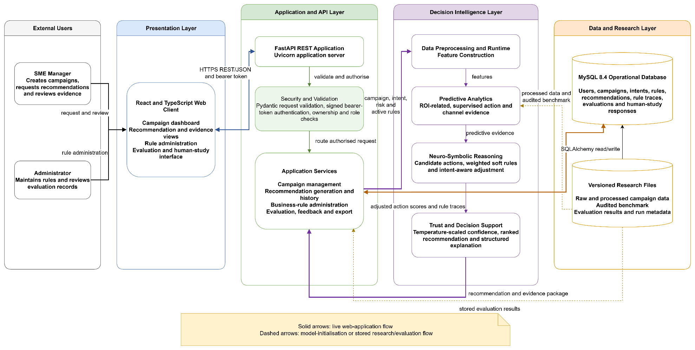
Figure 4.1 Overall Implemented System Architecture and Data Boundaries

Figure 4.1 presents the complete implemented system at a deliberately high level. A manager or administrator uses the browser interface, which exchanges REST/JSON messages with the FastAPI boundary. Request controls perform validation, authentication, ownership and role checks before application services load the campaign context, selected intent and active rules. The recommendation service then invokes RecommendationEngine and receives a bounded evidence package containing the selected action, ranked alternatives, confidence, explanation and rule traces. Operational records are written through SQLAlchemy to MySQL, whereas the engine is initialised from versioned research artefacts. The returned package supports human review only; no advertising platform or campaign budget is changed automatically.
During an operational request, an authenticated manager selects a campaign and business intent in the React interface. The interface sends the decision context to FastAPI, which validates the payload and loads the campaign, intent and active business rules through SQLAlchemy. The predictive and attribution components generate performance and channel evidence before the candidate-action module creates the bounded actions Increase, Maintain, Reduce and Investigate. Weighted soft rules, intent alignment and any selected risk-tolerance offset then adjust the action scores. Temperature calibration produces the displayed confidence, and the explanation component constructs the Driver, Implication, Action, Caveat and Intent fields. The recommendation, alternatives and triggered-rule traces are committed before the evidence package is returned to the interface. The manager must still accept, defer, reject or investigate the recommendation; the prototype never executes a marketing change automatically.
Table 4.1: Implementation Status and Scope
Artefact | Implemented state | Verification boundary
Architecture and modules | Five executable layers with explicit Python/REST/database interfaces. | Repository structure and import-level tests confirm the layer mapping.
Web prototype | React interface, FastAPI API, campaign workflow, recommendation review, rule administration and evaluation views. | Frontend production build and API integration tests.
Decision method | Predictive evidence, attribution, four actions, soft rules, intent ranking, calibration and structured explanation. | Unit tests and the locked technical evaluation runner.
Data and evidence | Raw, processed and audited benchmark layers plus application and experiment records. | Source, schema, provenance and split checks.
Deployment | Local workstation only; MySQL container is the target database and SQLite is a test fallback. | No claim of public, cloud or autonomous production deployment.

Because the project delivers a software artefact, this section records concise and testable implementation requirements without duplicating the methodological rationale in Chapter 3. Each requirement is linked to observable verification evidence, while performance outcomes remain reserved for Chapter 5.
Table 4.2 Testable Functional and Non-Functional Requirements
ID | Requirement | Implemented verification
FR1 | Authenticate users, maintain signed sessions and restrict administrative rule functions by role. | Login, registration, password-change and forbidden-admin API tests.
FR2 | Create, edit, delete, list and idempotently import campaign records after validating supported channels and numeric fields. | Campaign CRUD, duplicate-import and invalid-channel API tests.
FR3 | Generate one ranked recommendation package from Increase, Maintain, Reduce and Investigate for a manager-selected intent. | Engine and end-to-end recommendation-flow tests.
FR4 | Return raw and calibrated confidence, ranked alternatives, predictive evidence, activated rules and a structured explanation. | Engine package assertions and recommendation-detail endpoint tests.
FR5 | Persist recommendation history, managerial decision and evaluation feedback without automatically updating model or rule weights. | Database-backed recommendation, decision and feedback tests.
FR6 | Execute baselines, ablations and the proposed method on the locked benchmark with recorded configurations and exports. | Confirmatory runner and run-register endpoints.
FR7 | Collect blinded, pseudonymous human-study responses and prevent duplicate participant-case submissions. | Counterbalancing, token, duplicate and export API tests.
NFR1 | Keep p95 recommendation latency below the two-second acceptance threshold defined in Chapter 3. | Per-case latency captured for later Chapter 5 analysis.
NFR2 | Reproduce a run from fixed data versions, split rule, seed, method identifier and configuration. | Run metadata, seed metrics and prediction exports.
NFR3 | Protect credentials and minimise identifiable participant or customer data. | scrypt password hashes, signed tokens, role checks and pseudonymous study records.
NFR4 | Expose uncertainty and retain human approval for every business action. | Confidence caveats, Investigate fallback and accept/defer/reject controls.
NFR5 | Allow model, rule, intent, calibration, explanation and interface components to be changed independently. | Layered modules, API boundary and rule records.

Data Pipeline Implementation
The preprocessing methodology planned in Sections 3.2.3 and 3.3 was implemented in system_components/data_management_layer/data_preprocessing/preprocessor.py. The batch function prepare_frame(path, imputation_fit_fraction=0.70) loads a campaign CSV and returns a chronologically ordered pandas DataFrame. The runtime function case_features(case) converts one validated API campaign dictionary into the 13 numerical values used by the decision engine. RecommendationEngine partitions the ordered frame chronologically and passes only the training partitions to the fitted preprocessing and learning components. Figure 4.2 follows this executed data, annotation and evidence route rather than repeating the Chapter 3 research workflow.
The implemented batch flow is deterministic. pandas.read_csv loads the file and drop_duplicates removes exact duplicate rows. The function rejects campaign frames containing annotation or reference-action fields, trims date text, replaces slash separators and accepts only a consistently applied D-M-YYYY or YYYY-M-D format. Mixed or invalid formats raise an error. Records are then sorted by Date and Campaign_ID, the nine non-derived model measures are coerced to numeric values, and medians are calculated from the earliest 70% only. A field whose training portion contains no usable numeric value causes the pipeline to fail; otherwise, the frozen medians fill missing values in all three partitions. NumPy then constructs click-through rate, conversion rate and lead-to-conversion rate with a zero fallback, while cost per conversion falls back to Acquisition_Cost when Conversions is zero. The returned frame stores the fit-row count and median dictionary in DataFrame.attrs and exposes the validated 13-feature model structure.
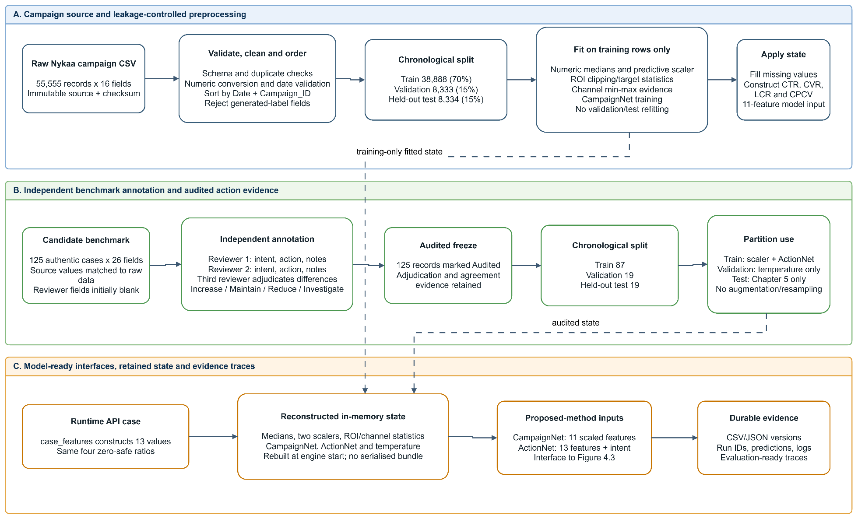
Figure 4.2 Implemented Data, Annotation and Evidence Pipeline

The immutable raw source, data/layers/01_raw_dataset_55555x16.csv, contains 55,555 records and 16 original fields. A separate versioned research layer, data/layers/02_processed_model_data.csv, contains 55,555 records and 31 fields: the original 16 fields plus 15 derived audit and research fields. It is retained for lineage and exploratory evidence and is not presented as the executable 13-feature model matrix. In the running implementation, prepare_frame and case_features construct CTR, conversion rate, lead-to-conversion rate and cost per conversion directly in memory from the validated source fields. This distinction prevents the persisted research layer from being confused with the runtime model interface.
The candidate benchmark contains 125 authentic campaign cases with 26 fields. Two reviewers independently recorded one of the three business intents and one of the four candidate actions, and a third reviewer adjudicated differences. The frozen benchmark contains 125 records marked Audited. It is partitioned chronologically into 87 training cases, 19 validation cases and 19 held-out test cases. The campaign source is split into 38,888 training, 8,333 validation and 8,334 held-out test records. PredictiveAttribution fits its 11-feature StandardScaler, ROI clipping bounds and target statistics, channel evidence and CampaignNet on the campaign training partition only. SupervisedActionEvidence fits its separate 13-feature scaler and intent-augmented ActionNet on the 87 audited training cases. The 19 validation cases fit only the calibration temperature, and the final 19 benchmark cases remain untouched until Chapter 5.
At recommendation time, case_features converts the validated campaign payload into the same 13-feature dictionary and recomputes the four ratios before model inference. The predictive component transforms this dictionary with the scaler fitted on the campaign training frame; the action component uses its own scaler fitted on the audited training frame. API validation normally supplies the required campaign measures. If a runtime numerical value is absent or empty, case_features currently substitutes zero rather than the batch median, and an unseen channel receives the neutral channel contribution of 0.5. These fallback behaviours are implementation constraints and are surfaced through the evidence and caveat mechanisms rather than being presented as learned values.
The implementation does not serialise a standalone preprocessing bundle with Joblib or Pickle. Batch imputation medians are retained in DataFrame.attrs, while StandardScaler instances, ROI target statistics and channel-normalisation values remain in memory inside the model objects and are reconstructed deterministically when RecommendationEngine starts. The durable artefacts are therefore the versioned raw and processed CSV files, IMPORT_AUDIT.json and run-level metadata rather than a separate preprocessor file. The executed environment uses pandas 2.1.4, NumPy 1.26.4, scikit-learn 1.7.2 and PyTorch 2.7.1+cu118; the wider environment is summarised in Section 4.5.
Two implementation choices narrow the broader Chapter 3 plan. General campaign-category encoding was not added to the numerical backbone: the three-value intent is one-hot encoded only inside the supervised action model, while channel is handled through a separate training-derived evidence lookup. General outlier removal was also avoided; only the ROI training target is percentile-clipped, preventing unusual campaign rows from being discarded. These decisions reduce fitted preprocessing state and keep the transformation trace auditable, but they also mean that runtime fallback values and in-memory preprocessing state must be recreated consistently during deployment.
Table 4.3 Persisted Data Structures and Evidence Traces
Store or entity | Key fields / indexes | Implementation purpose
Raw and processed CSV layers | Campaign_ID; 16 source fields; four derived ratios; date order. | Immutable source lineage and repeatable feature construction.
Audited benchmark | Reviewer labels, adjudicated intent/action, notes and Annotation_Status. | Locked human reference cases and validation/test partitions.
User, Intent and Campaign | Unique indexed email; campaign PK; user and intent FKs; campaign metrics. | Authenticated ownership, selected intent and operational input.
BusinessRule | Unique rule code; optional intent FK; condition, weight, priority and active state. | Versionable symbolic knowledge used by the rule engine.
Recommendation and RecommendationRule | Method, raw/calibrated confidence, evidence, ranking, latency; triggered rule detail. | Recommendation-level explanation and audit trace.
Evaluation and HumanStudyResponse | Recommendation FK; pseudonymous participant index; unique participant-case pair. | Feedback, blinded condition response and duplicate prevention.
Experiment outputs | Run ID, seed, split, versions, predictions, confidence, conflicts and latency. | Reproduction of Chapter 5 calculations from stored evidence.

The application database and versioned research files have distinct operational and evidential roles, but shared identifiers preserve traceability between them. The database supports interactive transactions, whereas CSV and JSON artefacts preserve frozen data and run outputs. Recommendation rows store the selected method, raw confidence, calibrated confidence, ranked actions, evidence, explanation and latency; RecommendationRule rows retain the rule, satisfaction state and diagnostic detail. Human-study records use a participant code rather than a name, enforce one response per participant-case pair, and exclude free-text comments from the analysis-ready export.

Proposed Method Implementation
The implemented method converts a validated campaign case and manager-selected intent into a bounded recommendation and evidence package through a fixed sequence of model, rule, intent, calibration and explanation operations. First, the predictive model estimates ROI-related evidence and maps it to initial action probabilities. When the audited action model is available, its four-class evidence is blended with the ROI-derived evidence. Historical channel contribution adds a small directional adjustment. The weighted rule engine then penalises actions that contradict performance, evidence sufficiency, cost, channel, budget or intent conditions. Intent-specific adjustments refine the ranking, after which temperature scaling converts scores into calibrated probabilities. The highest-ranked action is returned with alternatives, feature and channel attribution, activated rules and a structured explanation.

Model Architecture and Components
Figure 4.3 opens the implemented RecommendationEngine and shows how a validated campaign case becomes a bounded recommendation. The campaign feature vector feeds CampaignNet, ActionNet and the training-derived channel lookup. Their evidence enters a project-specific intent-aware, logic-constrained fusion and ranking stage. This stage keeps Increase, Maintain, Reduce and Investigate rankable, applies weighted soft-rule penalties and the Investigate fallback, then applies intent and risk adjustments before temperature scaling.
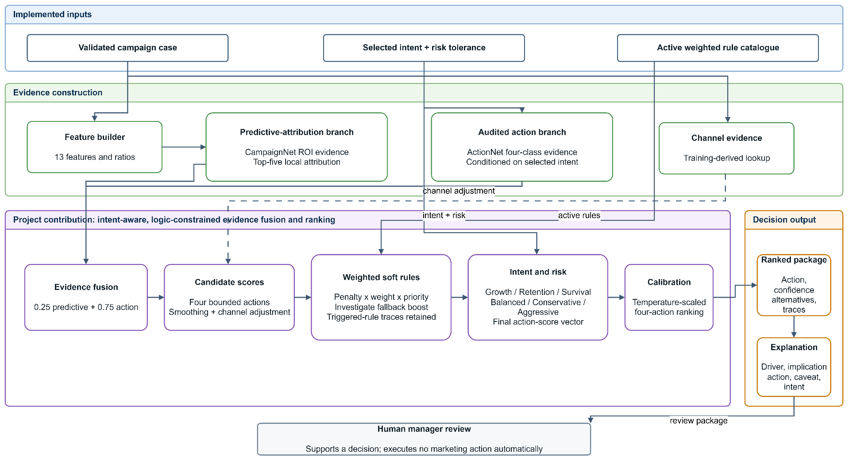
Figure 4.3 Internal Architecture of the Proposed Intent-Aware Neuro-Symbolic Recommendation Method
The predictive-attribution branch supplies ROI-derived action evidence and local sensitivity values; it does not directly execute a business action. The audited action branch supplies intent-conditioned four-class evidence, and channel evidence supplies a training-derived adjustment. After the final score vector is formed, validation-fitted temperature scaling produces the ranked probability distribution. The explanation component combines the selected action, confidence, attribution, channel evidence, activated rules and calibration status into Driver, Implication, Action, Caveat and Intent fields. The SME manager remains the final decision maker.
Table 4.4 Implemented Model and Software Components
Component | Input and dependency | Output / responsibility
Campaign preprocessor | CSV or API campaign fields; pandas and NumPy. | Validated 13-feature vector, ordered frame and four derived ratios.
ROI predictive model | Eleven leakage-controlled numeric predictors; StandardScaler and PyTorch. | Normalised ROI estimate and four initial action evidence values.
Action evidence model | Thirteen features plus three-value intent encoding from audited training cases. | Four-class supervised evidence for Increase, Maintain, Reduce and Investigate.
Attribution | Training data, selected channels and gradient-enabled predictive input. | Normalised channel evidence and top five absolute gradient-feature contributions.
Candidate generator | Four action scores. | Bounded action dictionary and ranked softmax list.
Weighted rule reasoner | Features, optional budget, selected intent and active rules. | Score penalties, Investigate boost and per-rule satisfaction traces.
Intent ranker | Selected Survival, Retention or Growth intent. | Action-specific intent adjustments and allowed-action consistency.
Calibration and explanation | Final logits, validation temperature, attribution and triggered rules. | Calibrated confidence plus Driver-Implication-Action-Caveat-Intent text.
FastAPI, React and SQLAlchemy | Validated REST payloads, signed session and ORM entities. | Human-review interface, persistent audit trail and evaluation export.

The ROI network is intentionally compact to match the available CPU environment and the project's bounded predictive role: an eleven-unit input is connected to a 16-unit ReLU hidden layer and one regression output. The training target is clipped to its first and ninety-ninth percentiles, standardised, and fitted using Adam for 80 epochs on the large training frame with learning rate 0.015 and weight decay 0.0001. The action network receives the 13 implemented features plus a three-element one-hot intent vector, uses a 24-unit ReLU hidden layer and produces four logits. On the smaller audited training partition it is fitted for 220 epochs with Adam, learning rate 0.012 and weight decay 0.0001.
Four actions are used throughout the system and baselines: Increase, Maintain, Reduce and Investigate. Bounding the output prevents free-form recommendations from bypassing the evaluation rubric. Channel evidence is calculated from training-set mean ROI and conversion information for each reported channel and normalised to [0,1]. For an individual case, feature attribution is the absolute product of the standardised input and its gradient for the selected predictive logit, normalised and limited to the five largest contributions. It is evidence for explanation, not a causal attribution claim.
The implemented catalogue contains exactly 14 default safeguards covering negative ROI, low conversion, low click-through rate, low engagement, insufficient observations, strong or exceptional signals, acquisition cost, channel saturation, budget feasibility, conflicting evidence and the three intent policies. Direct inspection of DEFAULT_RULES verified weights from 0.70 to 0.95 and integer priorities from one to three. The frozen configuration is identified as rule-catalogue-v1 in data/rule_catalogue_v1.json. Administrators may maintain rule records in normal use, but a changed catalogue requires a new configuration identifier and a new experimental run rather than silently altering existing evidence.
Typed REST endpoints separate the web interface from the model objects, while Pydantic validation and SQLAlchemy persistence provide explicit input and storage boundaries. Pydantic validates campaign fields and supported channels. SQLAlchemy persists the resulting recommendation, rule evidence and user decision. The interface requires an explicit user request to generate a recommendation and provides accept, defer or reject controls; it does not execute advertising changes. Confidence is displayed separately from managerial trust, because trust alignment is calculated later from human behaviour rather than generated as a model score.
At service start-up, SQLAlchemy creates the required tables and seeds the three intents, demonstration campaigns and default rule catalogue when the database is empty. The recommendation engine itself is initialised lazily on the first request, which avoids repeating model training for every endpoint call. A recommendation request loads the selected campaign and active rules within the authenticated user's scope, invokes the shared component engine, and commits the recommendation and applicable rule traces as one application workflow. The detail endpoint then reconstructs the evidence package from persisted values rather than silently recomputing it. This separation keeps interactive history stable even if a later development run changes model parameters or rules.
Figure 4.4 records the transactional schema used by the application. User, Campaign and Intent establish ownership and decision context; Recommendation stores the selected action, confidence and explanation; RecommendationRule preserves the rule evidence used for that decision; and Evaluation stores manager feedback. The human-study response structure remains evaluation-support data rather than part of the operational core diagram.
The relationships also provide an evidence trail from a user-owned campaign to its selected intent, generated recommendation, activated rule records and subsequent evaluation. Storing RecommendationRule as a separate associative entity allows multiple rule outcomes to be retained for one recommendation without duplicating the recommendation record. This structure supports historical reconstruction: a displayed recommendation can be traced to its campaign context, intent, confidence, explanation and rule evidence without rerunning the model.
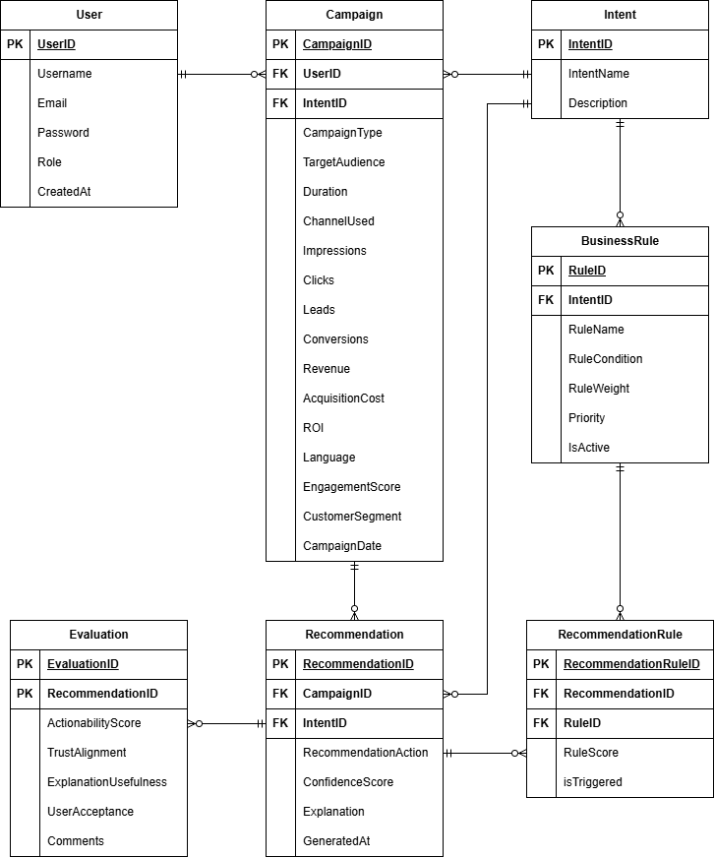

Figure 4.4 Implemented Application Entity Relationship Diagram
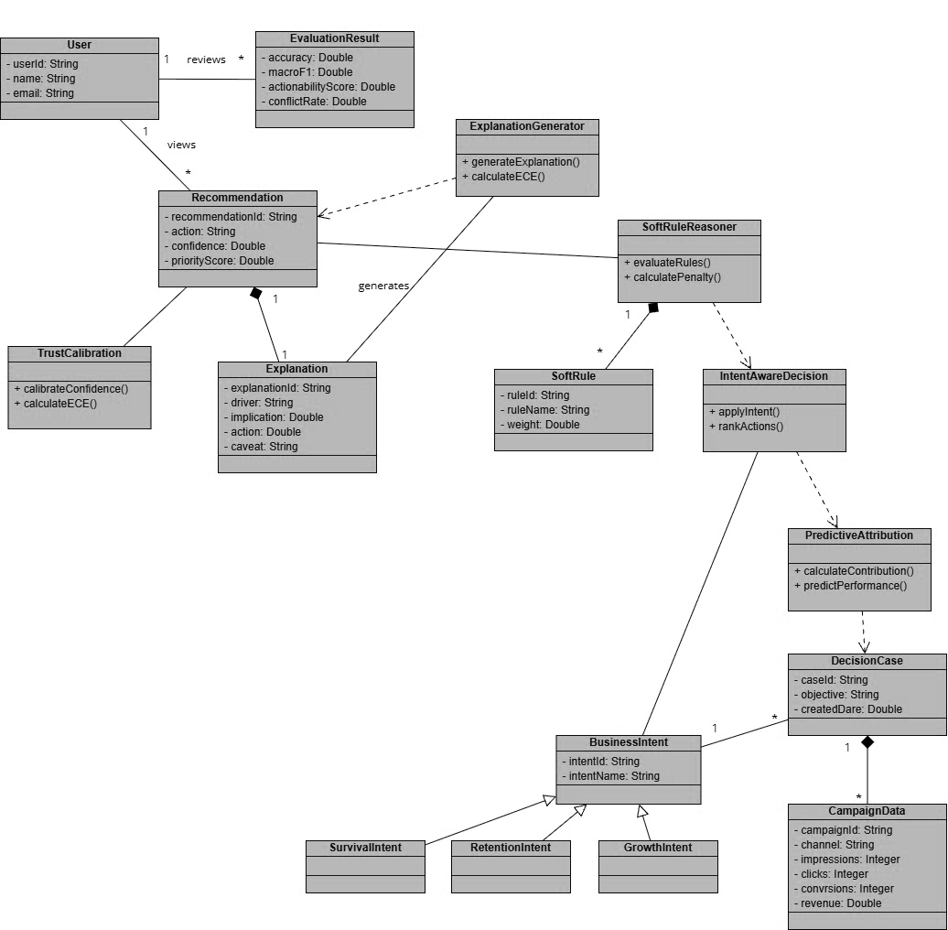
Implementation UML. The following UML views document the realised software modules and their interaction boundaries within Section 4.3.

Figure 4.5 Implemented Model and Service Class Diagram
Figure 4.5 maps the principal domain objects and service responsibilities. Campaign and Intent provide the decision context; the predictive, rule, calibration and explanation components contribute bounded evidence; and Recommendation aggregates the stored output used by the interface and evaluation support. The components exchange validated campaign features, bounded action scores, rule traces, calibrated probabilities and structured explanation fields rather than unrestricted text. This interface separation allows the predictive, reasoning and explanation modules to be tested independently while keeping Recommendation as the stable persistence boundary.
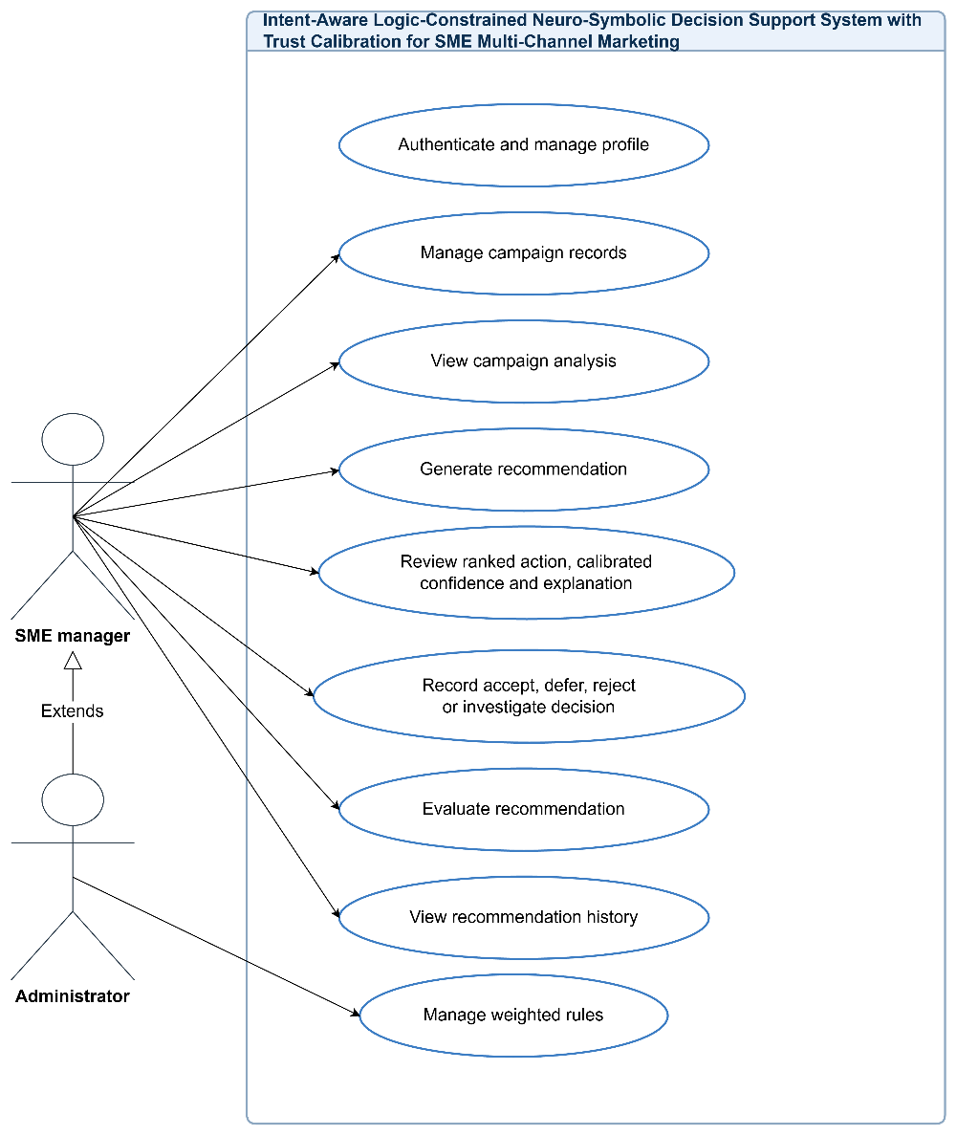

Figure 4.6 Implemented Use Cases
The implemented use cases remain decision-support functions. A manager maintains campaign context, requests and reviews a recommendation, records an evaluation and views history, while administrative rule maintenance is access-controlled. No use case automatically changes an advertising platform or budget. Authentication establishes the user scope, while administrator-only rule maintenance is separated from ordinary recommendation generation so that a manager cannot silently alter the reasoning policy during a controlled run.
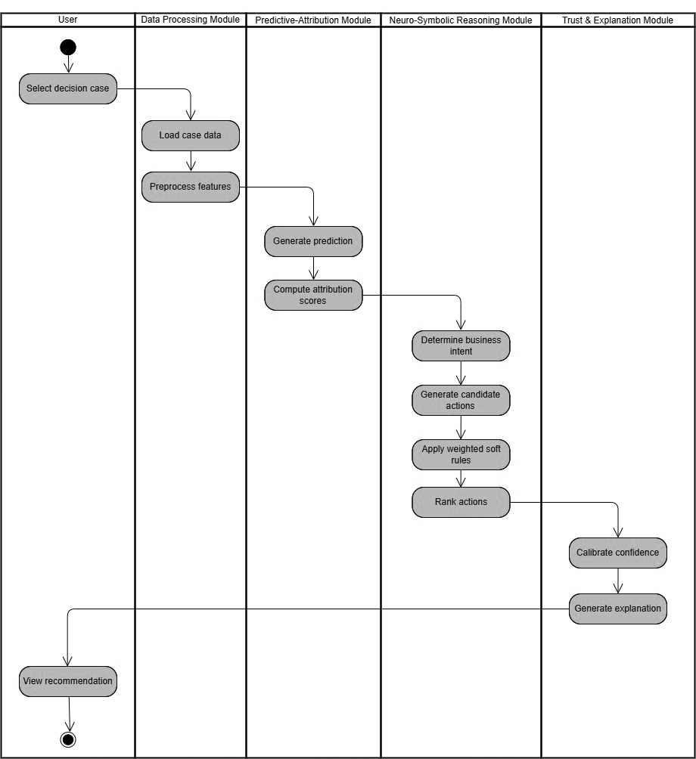
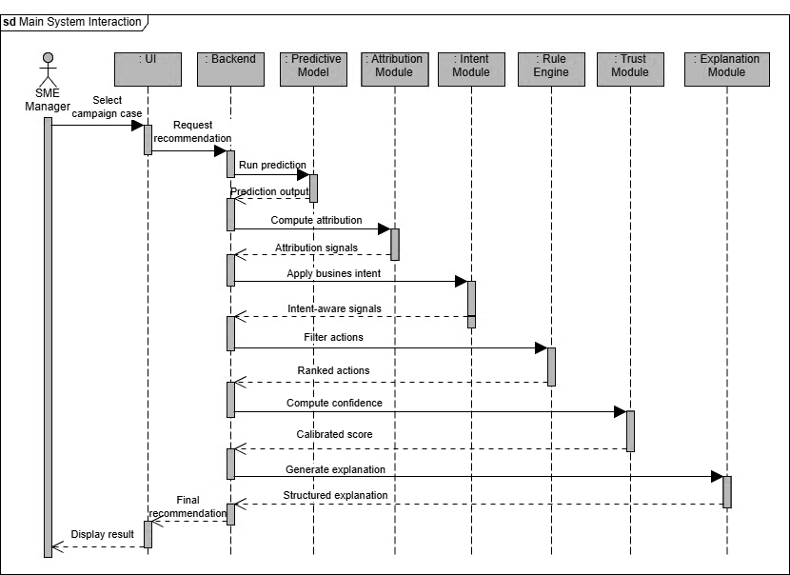
Figure 4.7 Implemented End-to-End Activity Workflow

Figure 4.8 Main Recommendation Interaction Sequence
Figures 4.7 and 4.8 show the same execution at complementary levels. The activity view follows data preparation, predictive evidence, attribution, intent-aware rule reasoning, calibration and explanation. The sequence view shows the browser request crossing the FastAPI boundary and returning a persisted evidence package. Together they distinguish component responsibility from call order. The implemented flow also contains explicit alternative paths: invalid campaign data returns a validation error, missing optional evidence prevents the related rule from firing, contradictory evidence raises the Investigate score, and unavailable audited calibration returns an uncalibrated warning instead of a reliability claim.
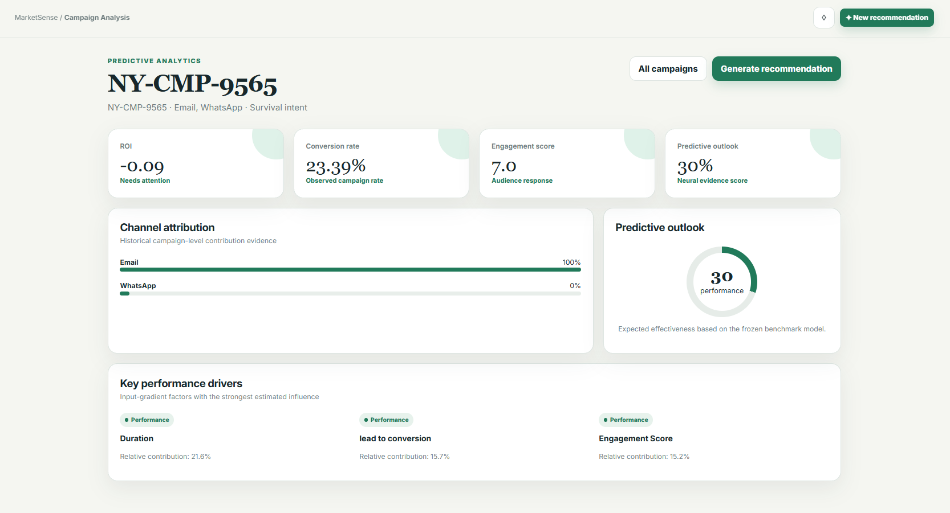
Interface and integration evidence. The selected screens demonstrate implemented integration rather than provide a user manual. They show the evidence available before a request, the explicit recommendation controls, the returned decision package and administrator-only rule configuration.

Figure 4.9 Campaign Analysis Interface
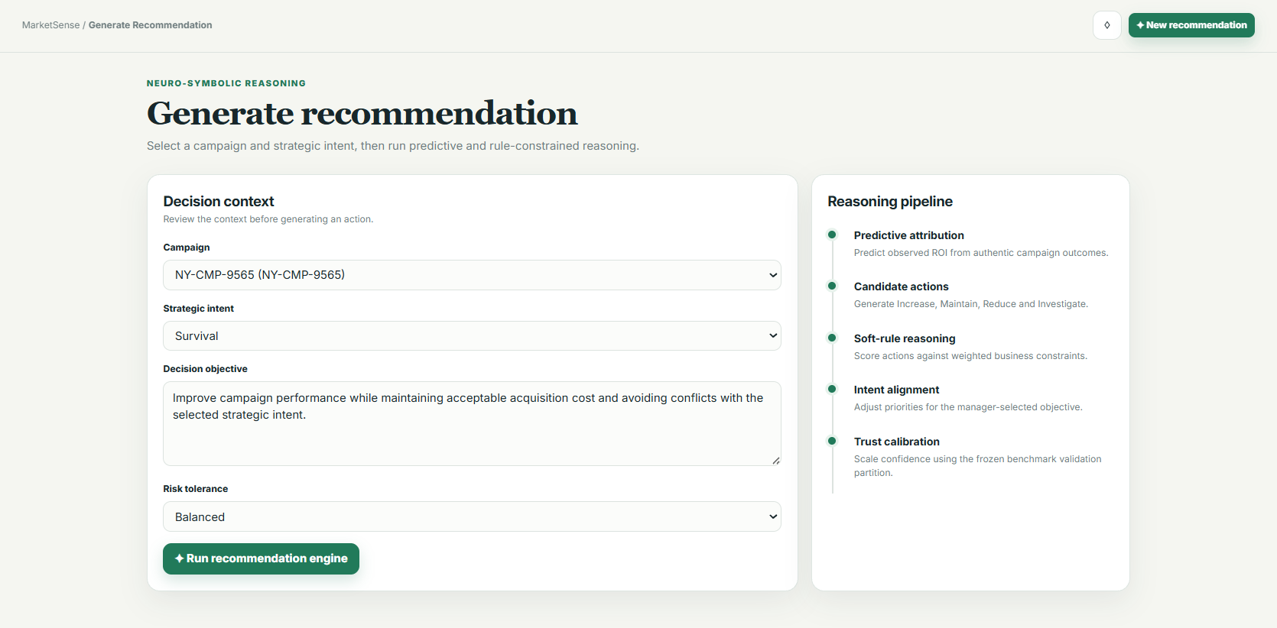
Figure 4.10 Recommendation Request Interface

Figure 4.11 Recommendation Evidence Interface
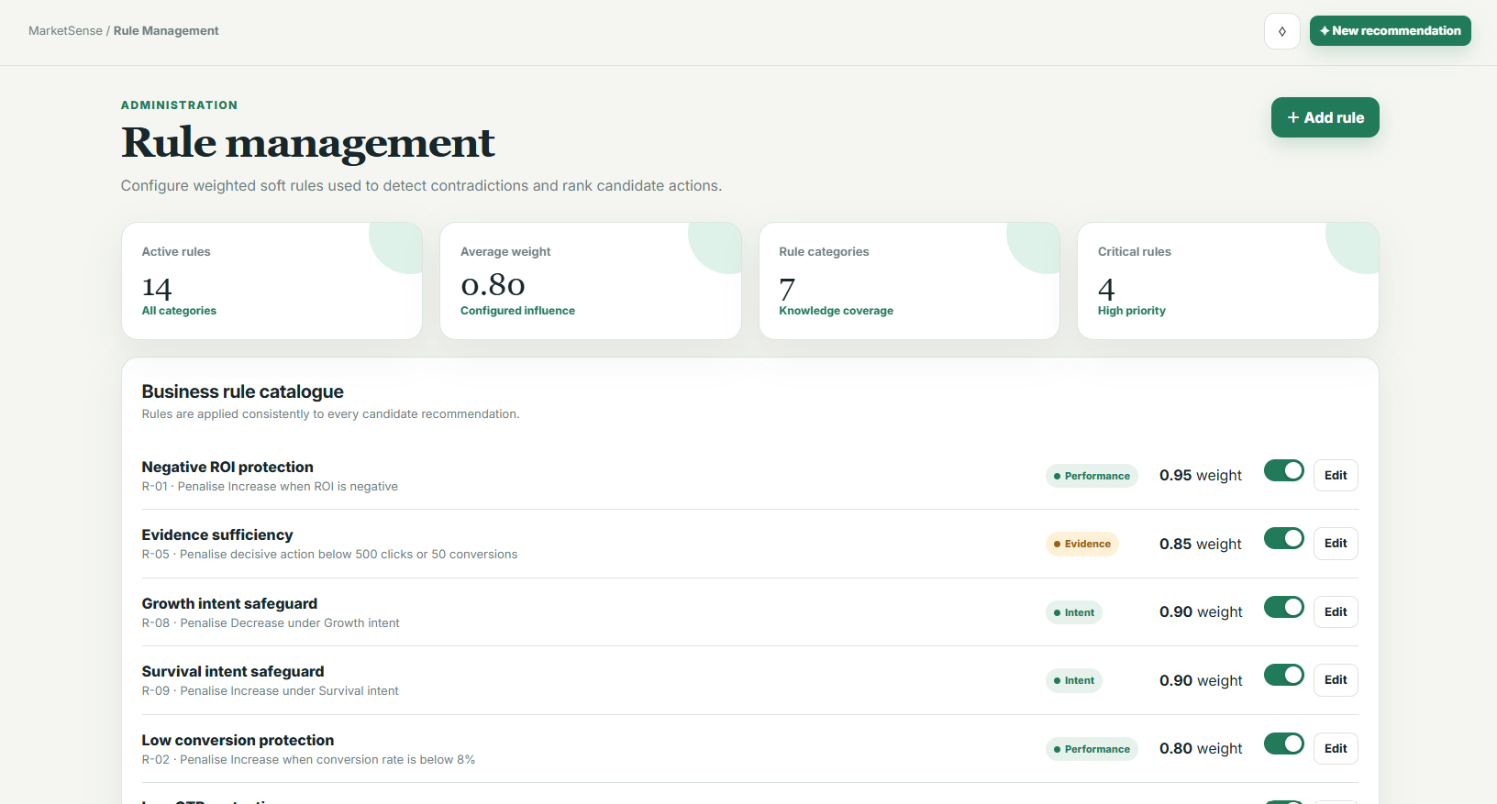

Figure 4.12 Rule Management Interface
The interface screenshots use demonstration records and therefore document implemented interaction flows rather than experimental outcomes. The Recommendation Details screen uses the prototype label 'calibrated trust'; in the implemented storage and evaluation logic this value is calibrated model confidence. Behavioural trust, appropriate reliance and overtrust are measured separately through participant responses.

Key Algorithms
This subsection formalises the computations that materially affect feature construction, model training, evidence fusion, neuro-symbolic reasoning, confidence calibration and explanation generation. Standardisation, mean-squared error, cross-entropy and softmax are established techniques and are not claimed as original contributions. Equations (4.4)-(4.7) describe project-specific mappings and score construction implemented in the prototype. Let $A=\left\{\text{Increase},\text{Maintain},\text{Reduce},\text{Investigate}\right\}$; $a∈A$ index an action; $i∈\left\{1,…,N\right\}$ index a campaign record; $j∈\left\{1,…,d\right\}$ index a feature; $r∈R$ index an active rule; $g∈\left\{\text{Growth},\text{Retention},\text{Survival}\right\}$ denote the manager-selected intent; and $ρ∈\left\{\text{Balanced},\text{Conservative},\text{Aggressive}\right\}$ denote risk tolerance. Monetary fields retain the currency recorded in the dataset, whereas rates, probabilities, ROI evidence and rule-satisfaction indicators are dimensionless.
Feature construction and leakage-controlled preprocessing
Four deterministic ratios are constructed from the validated campaign fields. They convert raw counts and cost values into comparable behavioural signals used by the predictive and action branches:
${\text{CTR}}_{i}=\frac{{\text{Clicks}}_{i}}{{\text{Impressions}}_{i}}, {\text{CVR}}_{i}=\frac{{\text{Conversions}}_{i}}{{\text{Clicks}}_{i}}$ (4.1a)
${\text{LCR}}_{i}=\frac{{\text{Conversions}}_{i}}{{\text{Leads}}_{i}}, {\text{CPCV}}_{i}=\frac{{\text{AcquisitionCost}}_{i}}{{\text{Conversions}}_{i}}$ (4.1b)
The implemented functions case_features and prepare_frame apply explicit zero-denominator controls. CTR is set to zero when impressions are zero, CVR is set to zero when clicks are zero, and LCR is set to zero when leads are zero. When conversions are zero, CPCV retains AcquisitionCost instead of performing an invalid division. These boundary rules are deterministic and do not learn information from the validation or test partitions.
For continuous feature $x_{ij}$, the standardised value is $z_{ij}$. The ROI target is clipped at the training-set first and ninety-ninth percentiles before it is standardised. All quantities carrying superscript $\text{tr}$ are fitted exclusively on the chronological training partition:
$z_{ij}=\frac{x_{ij}-μ_{j}^{\text{tr}}}{σ_{j}^{\text{tr}}}, y_{i}=\frac{\text{clip}\left({\text{ROI}}_{i},q_{0.01}^{\text{tr}},q_{0.99}^{\text{tr}}\right)-μ_{y}^{\text{tr}}}{σ_{y}^{\text{tr}}}$ (4.2)
Here, $μ_{j}^{\text{tr}}$ and $σ_{j}^{\text{tr}}$ are the training-set mean and standard deviation of feature $j$; $q_{0.01}^{\text{tr}}$ and $q_{0.99}^{\text{tr}}$ are the corresponding ROI clipping bounds; and $μ_{y}^{\text{tr}}$ and $σ_{y}^{\text{tr}}$ are the mean and standard deviation of the clipped training ROI. The fitted objects are then reused unchanged for validation, test and runtime inputs. This implements the leakage-control protocol specified in Chapter 3 while documenting the actual execution behaviour in Chapter 4.
Predictive and supervised learning objectives
CampaignNet, denoted by $f_{θ}$, maps the standardised campaign vector $z_{i}∈R^{d}$ to a standardised ROI prediction. Its parameters $θ$ minimise mean-squared error over $N$ campaign training records:
$L_{\text{ROI}\left(θ\right)}=\frac{1}{N}\sum_{i=1}^{N}{{\left[f_{θ\left(z_{i}\right)}-y_{i}\right]}^{2}}$ (4.3a)
ActionNet, denoted by $h_{φ}$, receives the audited campaign features and the one-hot intent vector $u_{i}$. Its parameters $φ$ minimise four-class cross-entropy over $M$ audited training cases:
$L_{\text{act}\left(φ\right)}=-\frac{1}{M}\sum_{i=1}^{M}{\sum_{a∈A}{1\left[y_{i}=a\right]\text{log}p_{φ\left(a | z_{i},u_{i}\right)}}}$ (4.3b)
In Equation (4.3b), $1\left[y_{i}=a\right]$ equals one when the audited action label for case $i$ is $a$, and zero otherwise. The probability $p_{φ\left(a | z_{i},u_{i}\right)}$ is obtained from the four ActionNet logits. CampaignNet is trained for 80 full-batch epochs using Adam with learning rate 0.015 and weight decay ${10}^{-4}$. ActionNet is trained for 220 full-batch epochs using Adam with learning rate 0.012 and the same weight decay. These are implementation settings rather than performance results.
Predictive evidence, fusion and neuro-symbolic scoring
At inference, CampaignNet's standardised output is converted back to the ROI scale to obtain $\hat{r}$. The implementation then maps $\hat{r}$ to a four-element predictive logit vector. The element order is Increase, Maintain, Reduce and Investigate, and the constants are fixed implementation thresholds in the model module rather than learned values:
$l^{\text{ROI}\left(\hat{r}\right)}={\left(\frac{\hat{r}-1.25}{1.5}, 0.8-\frac{\left|\hat{r}-1.0\right|}{1.5},\frac{0.5-\hat{r}}{1.2}, -0.1\right)}^{T}$ (4.4)
Applying softmax to Equation (4.4) produces $p_{a}^{\text{ROI}}$. When ActionNet is available, its probability $p_{a}^{\text{act}}$ is fused with the ROI-derived probability. A uniform smoothing mass is subsequently applied across the four actions:
$p_{a}^{f}=0.25p_{a}^{\text{ROI}}+0.75p_{a}^{\text{act}}, {\tilde{p}}_{a}=0.90p_{a}^{f}+\frac{0.10}{4}$ (4.5)
The weights 0.25 and 0.75 specify the implemented contribution of predictive and supervised evidence. Smoothing prevents any candidate from receiving an exact zero before the rule and intent adjustments. If ActionNet is unavailable, the implementation sets $p_{a}^{f}=p_{a}^{\text{ROI}}$ and records a supervised-evidence fallback caveat instead of presenting the output as fully fused.
Let $c∈\left[0,1\right]$ be the mean normalised historical signal for the selected channel. The implemented channel adjustments are:
$$C_{\text{Increase}\left(c\right)}=c-0.5, C_{\text{Maintain}\left(c\right)}=0.25-\left|c-0.5\right|, C_{\text{Reduce}\left(c\right)}=0.5-c, C_{\text{Investigate}\left(c\right)}=0$$
An unseen channel receives the neutral value c = 0.5. The intent lookup vectors, written in the same action order, are:
$$I_{\text{Growth}}=\left(1.0,0.2,-1.0,-0.1\right), I_{\text{Retention}}=\left(0.2,1.0,-0.5,0.1\right), I_{\text{Survival}}=\left(-1.0,0.4,1.0,0.3\right)$$
The corresponding risk-offset vectors are:
$$R\left(\text{Balanced}\right)=\left(0,0,0,0\right), R\left(\text{Conservative}\right)=\left(-0.18,0,0,0.12\right), R\left(\text{Aggressive}\right)=\left(0.14,0,0,-0.08\right)$$
For active rule $r$, let $w_{r}∈\left[0.70,0.95\right]$ be its stored weight, $q_{r}=\text{max}\left(1,{\text{priority}}_{r}\right)$ its priority multiplier, and $V_{r,a}∈\left\{0,1\right\}$ its action-violation indicator. The implemented catalogue contains $\left|R\right|=14$ active rules with priorities from one to three. Combining the smoothed probability, channel evidence, intent, risk and weighted soft-rule penalty gives the pre-calibration action score:
$s_{a}={\tilde{p}}_{a}+0.10C_{a\left(c\right)}+0.20I_{g,a}+R_{a\left(ρ\right)}-0.20\sum_{\left(r∈R\right)w_{r}}{q_{r}V_{r,a}}$ (4.6)
Equation (4.6) implements soft constraints: a rule violation reduces the affected action score but does not remove the action from the candidate set. To make uncertainty reviewable, each violation attached to a non-Investigate action also contributes a smaller weighted increase to the Investigate score:
$s_{\text{Investigate}}←s_{\text{Investigate}}+0.10\sum_{r∈R\sum_{\left(a∈A,a≠\text{Investigate}\right)w_{r}}{V_{r,a}}}{}$ (4.7)
This fallback mechanism makes Investigate more competitive when the available evidence conflicts with active operational safeguards. It does not automatically reject or execute an action; the final recommendation remains subject to SME manager review.
Validation-only calibration and final decision
Temperature scaling is fitted using audited validation logits only. Let ${\vec{s}}_{i}={\left(s_{i,a}\right)}_{a∈A}$ be the complete score vector for validation case $i$ and let $y_{i}∈A$ be its audited action label. The implemented limited-memory BFGS procedure minimises validation negative log-likelihood and constrains the returned temperature to $0.5≤T≤5$:
$T^{*}=\arg{\min_{0.5≤T≤5}\left[-\sum_{i=1}^{N_{\text{val}}}{\text{log}\left(\text{softmax}{\left(\frac{{\vec{s}}_{i}}{T}\right)}_{y_{i}}\right)}\right]}$ (4.8)
If the audited calibration gate is unavailable, the system uses $T=1$ and adds an uncalibrated-evidence caveat. Otherwise, the fitted $T^{*}$ converts the final scores into calibrated action probabilities:
$P_{T\left(a | x,g,ρ\right)}=\frac{\exp\left(\frac{s_{a}}{T^{*}}\right)}{\sum_{\left(b∈A\right)exp}{}\left(\frac{s_{b}}{T^{*}}\right)}$ (4.9a)
$\hat{a}=\arg{\max_{a∈A}{P_{T\left(a | x,g,ρ\right)}}}$ (4.9b)
The recommendation $\hat{a}$ is the highest-ranked action, and its displayed confidence is $P_{T\left(\hat{a} | x,g,ρ\right)}$. The interface labels confidence as High when the probability is at least 0.75, Medium when it is at least 0.50 but below 0.75, and Low otherwise. Temperature scaling changes the probability sharpness but not the ordering of the scores.
Local predictive attribution
The predictive explanation uses a gradient-times-input calculation. Let $a^{*}$ be the action selected by the ROI-derived predictive branch, $l_{a^{*}}$ its corresponding logit, and $z_{j}$ the standardised value of feature $j$. The normalised local attribution is:
$α_{j}=\frac{\left|\frac{z_{j}\left(∂l_{a^{*}}\right)}{∂z_{j}}\right|}{D}$ (4.10)
For clarity, define $G=\sum_{k}{\left|\frac{z_{k}\left(∂l_{a^{*}}\right)}{∂z_{k}}\right|}$. The implementation sets $D=G$ when $G>0$, and $D=1$ otherwise. Consequently, the attribution values satisfy $α_{j}≥0$ and, whenever $G>0$, $\sum_{j}{α_{j}}=1$. The five largest values are retained as local sensitivity evidence. They indicate which inputs most influenced the local predictive logit; they are not causal effects.
Algorithm 4.1 organises the training-only fitting and validation-only calibration procedure. Algorithm 4.2 then organises one complete recommendation request. Together, the two algorithms cover all computations in Equations (4.1a)-(4.10) without translating routine pandas, PyTorch, FastAPI or SQLAlchemy calls line by line.
Algorithm 4.1 Model Initialisation and Validation-Only Calibration
Require: versioned campaign data $D_{\text{raw}}$; audited benchmark $B$; seed 42; CampaignNet $f_{θ}$; ActionNet $h_{φ}$; Adam learning rates 0.015 and 0.012; weight decay ${10}^{-4}$; 80 and 220 epochs; and LBFGS calibration with learning rate 0.05 and at most 60 iterations.
Ensure: fitted engine state E containing the preprocessing statistics, trained models, channel evidence, temperature and calibration status; the test partitions remain untouched.

1: | Set the NumPy and PyTorch random seeds to $42$ | ▷ Fix the initial state
2: | $$D←PrepareFrame\left(D_{\text{raw}},0.70\right)$$ | ▷ Clean, order and impute
3: | Construct CTR, CVR, LCR and CPCV using Equations (4.1a)-(4.1b) | ▷ Derive deterministic ratios
4: | Split $D_{\text{train}}:D_{\text{val}}:D_{\text{test}}=70:15:15$ chronologically | ▷ Preserve temporal order
5: | Fit $S_{\text{ROI}}, μ_{y}, σ_{y}, q_{0.01}^{\text{tr}}, q_{0.99}^{\text{tr}}$ on $D_{\text{train}}$ using Equation (4.2) | ▷ Training-only fitting
6: | Initialise CampaignNet parameters $θ$ | ▷ 11-16-1 network
7: | for $epoch∈\left\{1,…,80\right\}$ do | ▷ Full-batch optimisation
8: | $$z←S_{\text{ROI}\left(D_{\text{train}\left[F_{\text{ROI}}\right]}\right)}$$ | ▷ Scale 11 inputs
9: | $$\hat{y}←f_{θ\left(z\right)}$$ | ▷ Predict normalised ROI
10: | Compute $L_{\text{ROI}}$ using Equation (4.3a) | ▷ Compute mean-squared error
11: | $$θ←Adam\left(θ,∇_{θ}L_{\text{ROI}};η=0.015,λ={10}^{-4}\right)$$ | ▷ Update CampaignNet
12: | end for
13: | $C_{\text{train}}←ChannelEvidence\left(D_{\text{train}}\right)$ with frozen min-max bounds | ▷ Freeze channel statistics
14: | Validate $B$ and split it chronologically into $B_{\text{train}}:B_{\text{val}}:B_{\text{test}}=70:15:15$ | ▷ Keep B_test untouched
15: | Fit $S_{\text{act}}$ on 13 $B_{\text{train}}$ features and one-hot encode the audited intent | ▷ Training-only action inputs
16: | Initialise ActionNet parameters $φ$ | ▷ 16-24-4 network
17: | for $epoch∈\left\{1,…,220\right\}$ do | ▷ Full-batch optimisation
18: | $$l_{\text{act}}←h_{φ}\left(S_{\text{act}\left(B_{\text{train}}\right)},OneHot\left(g_{\text{train}}\right)\right)$$ | ▷ Predict four action logits
19: | Compute $L_{\text{act}}$ using Equation (4.3b) | ▷ Compute cross-entropy
20: | $$φ←Adam\left(φ,∇_{φ}L_{\text{act}};η=0.012,λ={10}^{-4}\right)$$ | ▷ Update ActionNet
21: | end for
22: | for each audited validation case $\left(x_{i},g_{i},y_{i}\right)∈B_{\text{val}}$ do | ▷ Calibration data only
23: | $s_{i}←Score\left(x_{i},g_{i}\right)$ using Equations (4.4)-(4.7) | ▷ Use the complete score
24: | end for
25: | if the audited validation gate is available then | ▷ Require at least 120 audited cases
26: | $T^{*}←FitTemperature\left(S_{\text{val}},Y_{\text{val}}\right)$ using Equation (4.8); constrain $T^{*}∈\left[0.5,5\right]$ | ▷ Validation-only calibration
27: | else | ▷ Fallback branch
28: | $T^{*}←1$ and set calibration status to unavailable | ▷ Do not claim calibration
29: | end if
30: | $E←\left\{S_{\text{ROI}},μ_{y},σ_{y},θ,C_{\text{train}},S_{\text{act}},φ,T^{*}\right\}$ with its calibration status | ▷ Assemble in-memory state
31: | return $E$ | ▷ Engine ready for inference

Algorithm 4.2 Intent-Aware Logic-Constrained Recommendation Inference
Require: validated campaign $x$; intent $g∈\left\{\text{Growth},\text{Retention},\text{Survival}\right\}$; risk tolerance $ρ∈\left\{\text{Balanced},\text{Conservative},\text{Aggressive}\right\}$; active versioned rule catalogue $R$; fitted engine state $E$; and action set $A=\left\{\text{Increase},\text{Maintain},\text{Reduce},\text{Investigate}\right\}$.
Ensure: persistent recommendation and evidence package P for SME manager review; no marketing action is executed automatically.

1: | Validate $x,g,ρ,R$ | ▷ Reject invalid requests
2: | $v←CaseFeatures\left(x\right)$ using Equations (4.1a)-(4.1b) | ▷ Construct 13 runtime features
3: | $$z_{\text{ROI}}←S_{\text{ROI}\left(v\left[F_{\text{ROI}}\right]\right)}$$ | ▷ Apply frozen training scaler
4: | $$\hat{r}←σ_{y}f_{θ}\left(z_{\text{ROI}}\right)+μ_{y}$$ | ▷ Denormalise predicted ROI
5: | $p^{ROI}←softmax\left(l^{ROI\left(\hat{r}\right)}\right)$ using Equation (4.4) | ▷ Create predictive evidence
6: | $α←GradientInput\left(z_{\text{ROI}},l^{ROI}\right)$ using Equation (4.10) | ▷ Retain the top five drivers
7: | if ActionNet is available then | ▷ Audited-action branch
8: | $$p^{act}←softmax\left(h_{φ}\left(S_{\text{act}\left(v\right)},OneHot\left(g\right)\right)\right)$$ | ▷ Create intent-conditioned evidence
9: | $\tilde{p}←Fuse\left(p^{ROI},p^{act}\right)$ using Equation (4.5) | ▷ Apply 0.25/0.75 fusion and smoothing
10: | else | ▷ Predictive-only fallback
11: | $\tilde{p}←p^{ROI}$ and append the supervised-evidence caveat | ▷ Record fallback
12: | end if
13: | $c←ChannelMean\left(C_{\text{train}}\right)$; use $c←0.5$ for an unseen channel | ▷ Obtain historical evidence
14: | for each action $a∈A$ do | ▷ Initialise four candidates
15: | $$s_{a}←{\tilde{p}}_{a}+0.10C_{a\left(c\right)}+0.20I_{g,a}+R_{a\left(ρ\right)}$$ | ▷ Add channel, intent and risk terms
16: | for each active rule $r∈R$ do | ▷ Evaluate applicable safeguards
17: | $s_{a}←s_{a}-0.20w_{r}q_{r}V_{r,a}$ using Equation (4.6) | ▷ Apply weighted soft penalty
18: | end for
19: | end for
20: | $s_{\text{Investigate}}←RuleFallback\left(s,R\right)$ using Equation (4.7) | ▷ Boost fallback after violations
21: | if calibrated $T^{*}$ is available then | ▷ Calibrated ranking
22: | $P_{T\left(a | x,g,ρ\right)}←Calibrate\left(s_{a},T^{*}\right)$ using Equation (4.9a) | ▷ Temperature-scale the scores
23: | else | ▷ Uncalibrated fallback
24: | $P_{T\left(a | x,g,ρ\right)}←softmax\left(s_{a}\right)$; append the calibration caveat | ▷ Use T = 1
25: | end if
26: | $\hat{a}←SelectHighest\left(P_{T}\right)$ using Equation (4.9b) | ▷ Select the highest-ranked action
27: | Assign confidence level from $P_{T\left(\hat{a} | x,g,ρ\right)}$: High $≥0.75$, Medium $≥0.50$, otherwise Low | ▷ Communicate reliance
28: | Construct Driver, Implication, Action, Caveat and Intent from $α,c$ and activated rules | ▷ Generate structured explanation
29: | Assemble evidence package $P$ from the selected action, ranked alternatives, confidence, explanation, attribution, rule traces and latency | ▷ Assemble the evidence package
30: | Persist $P$ and return it for human review | ▷ Do not execute a marketing action

Baseline Implementation
Four baselines were implemented within the same evaluation package as the proposed method so that data partitions, action labels, output fields and metric functions remain comparable. They consume the same audited chronological partitions, use the same four action labels and emit the same prediction, confidence, top-two, explanation and latency structure. Common metric functions then evaluate every system, which avoids method-specific scoring code.
Table 4.5 Baseline Implementation and Comparison Parity
Condition | Implementation | Parity control
A: Heuristic scorecard | Fixed ROI, conversion, engagement and ambiguity thresholds produce action scores followed by softmax. | No fitted labels; identical held-out cases, actions and output schema.
B: Predictive only | Training-only standardisation and nearest-class-centroid probabilities over the 13 implemented features. | Same benchmark training and test partitions; no attribution, intent or rules.
C: Predictive + attribution | Baseline B logits adjusted by normalised training-set channel evidence. | Same channel evidence source and output schema; no higher-level reasoning.
D: Post-hoc hard-rule overlay | Baseline B predictions are filtered after scoring when the shared conflict catalogue rejects an action. | Uses the same conflict definitions, but hard rejection rather than weighted integration.
Proposed ablations | Backbone, without rules, without intent and without calibration variants use the same engine switches. | All other settings, data, actions, traces and metrics remain fixed.

The deterministic baselines are executed once per frozen partition because repeated runs would reproduce the same outputs, whereas the neural conditions retain seed-level variation across seeds 42, 52 and 62. The proposed neural conditions are executed with seeds 42, 52 and 62, and their mean metrics and seed-level outputs are retained. Calibration is always fitted on validation data, never the held-out test set. The runner records per-case latency and the same correctness, top-two, scenario-fit, logical-conflict and calibration inputs for each method.

Experimental Environment and Configuration

Table 4.6 records the executable environment and controls used for the prototype, while Chapter 3 retains the broader reproducibility protocol. Backend versions were verified from the active Python environment and requirements.txt; frontend versions were verified from package.json and pnpm-lock.yaml. The executed capture, including host, runtime and configured-service status, is retained as outputs/environment_ch4_20260801.json. A configured dependency is not described as executed when its runtime was unavailable during capture.
Table 4.6 Experimental Environment and Configuration
Area | Implemented configuration
Host | Windows 11 Home Single Language 64-bit (10.0.26200); Intel Core i5-1235U (10 cores, 12 logical processors); 23.7 GB usable RAM; local execution.
Backend | Python 3.11.9 in the active project environment; FastAPI 0.139.0; Uvicorn 0.51.0; SQLAlchemy 2.0.46; PyMySQL 1.1.2.
Model and data | PyTorch 2.7.1+cu118; pandas 2.1.4; scikit-learn 1.7.2; NumPy 1.26.4 in the executed project environment.
Frontend | React/React DOM 19.2.7; TypeScript 7.0.2; Vite 8.1.4; Node.js 24.18.0; pnpm 11.16.0; committed pnpm lockfile.
Persistence | MySQL image mysql:8.4 configured in docker-compose.yml; Docker CLI was unavailable during the final environment capture. Temporary SQLite is executed for isolated API tests.
Execution controls | Chronological 70/15/15 split; seeds 42, 52 and 62; five ECE bins; 2,000 bootstrap samples in the evaluation runner.
External services | None required at inference time; no cloud AI, advertising-platform, CRM or ERP connection.

Implementation Constraints
The principal implementation constraint is the imbalance between the large campaign source and the much smaller independently audited decision benchmark. The campaign source is large enough for the ROI model, but only 125 cases have independently audited intent and action labels. A chronological 15% test partition is therefore small, and the action network must remain compact. The implementation uses a shallow multilayer perceptron, a four-action vocabulary and an explicit rule layer rather than a larger end-to-end model. This compromise reduces compute cost and improves auditability, but it limits action granularity and the precision of subgroup analysis. Campaign-level fields also support association and gradient attribution only; they do not establish causal channel effects or customer-level behaviour.
The prototype runs on a CPU workstation with no dedicated production infrastructure. Training epochs, hidden layer sizes and four bounded actions were selected to keep repeatable runs practical on the available hardware. MySQL is containerised locally, while automated tests substitute temporary SQLite through the same ORM. This improves portability but does not test production-scale concurrency, failover or database operations. Similarly, there is no live campaign execution or data synchronisation; managers must review and apply recommendations outside the system.
The implemented security controls support local research use but do not satisfy the broader operational requirements of an Internet-facing deployment. Passwords are stored with salted scrypt hashes, session tokens are HMAC-signed with an eight-hour expiry, administrative rule operations require an administrator role, campaign payloads are validated and browser origins are restricted to the local frontend. A non-development installation must replace the default token secret with a long random environment value. TLS termination, secret rotation, rate limiting, account recovery, central audit monitoring, managed backup and penetration testing were not deployed.
Privacy and human-control constraints shaped both storage and interface behaviour. The recommendation engine does not require customer names, social-media credentials or behavioural tracking identifiers. Human-study records use pseudonymous participant codes, store consent status and omit free-text comments from analysis export. The interface does not infer a user's business intent; the manager selects Survival, Retention or Growth. It also does not treat confidence as trust. Trust alignment and overtrust require participant behaviour and remain evaluation constructs.
Fallback controls are explicit. Missing budget prevents the budget rule from firing rather than inventing a value. Conflicting or insufficient evidence increases the Investigate score. If audited calibration is unavailable, the system exposes an uncalibrated evidence warning. Every recommendation still requires a human accept, defer, reject or review action. These controls prioritise safe incompleteness over unsupported certainty.
Evaluation traceability was folded into the implementation instead of treated as a separate interface chapter. R001-R006 identify the source audit, technical comparison, calibration/reliance study, logic experiment, intent experiment and explanation experiment. The technical runner stores the dataset and training paths, chronological split, record counts, seeds, ECE bins, bootstrap count, temperature and calibration status in run_metadata.json. Predictions.csv stores Campaign_ID, date, intent, reference action, system, seed, prediction, confidence, top two, conflict reasons and latency. The database separately preserves interactive recommendation evidence, rule traces, managerial decisions and study responses. These records allow Chapter 5 tables to be regenerated without copying results into this implementation chapter.

Chapter Summary and Evaluation
This chapter documented how the Chapter 3 design was realised as a bounded local prototype without reporting comparative outcomes. Figure 4.1 established the complete web-system architecture, storage boundaries and human-review control. Figure 4.2 traced the actual campaign-data and independently audited benchmark routes, including chronological splitting, training-only fitting, validation-only calibration and the held-out test boundary. Figure 4.3 opened the proposed AI method and identified the intent-aware, logic-constrained evidence-fusion and ranking contribution. Figures 4.4-4.16 then retained the ERD, UML, interaction, interface and supporting workflow views needed to explain the implemented software without duplicating the three core technical figures.
Equations (4.1a)-(4.10) define the consequential computations, while Algorithms 4.1 and 4.2 organise training, validation-only calibration and one complete inference request. Section 4.4 documents fair baseline implementation without adding unnecessary baseline diagrams or algorithms. Sections 4.5 and 4.6 record the verified local environment, implementation constraints, security and privacy controls, fallbacks and evaluation traceability. These implemented mechanisms establish readiness for the measurements and comparisons reported in Chapter 5; the artefact remains a local decision-support prototype rather than a public or autonomous production deployment.

Chapter 5

Experiments, Results and Discussion

Experiments, Results and Discussion
A short introduction that describes what will be included in this chapter.
IMPORTANT NOTE TO STUDENTS: Include details about:

- Implementation
A detailed description of how you actually carried out the implementation (e.g., coding, etc.) of your system/prototype.
- Include code snippets and descriptions to show how the requirements of the application/prototype have been met –
  - For Smart Campus projects, code snippets of the MQTT protocol for both client side and server side has to be included with explanation.
- Include descriptions of important settings - Setting for server, network protocol, IP, database, security
- Note: this should not be a chronological account of the work you carried out.

- Testing
All test cases that have been carried out must be provided - To tabulate the test cases in tables

Note: Students may also opt to split Implementation and Testing into 2 separate chapters.

Sub-section 1 Heading
Sub-sections should be used to divide the chapter into logical parts.

Sub-subsection Heading
Sub-section numbering should be limited to a maximum of 3 levels (e.g. 5.3.1) in order to avoid confusion.

Sub-section 2 Heading

Sub-section 1 Heading
Sub-sections should be used to divide the chapter into logical parts.

Sub-subsection Heading
Sub-section numbering should be limited to a maximum of 3 levels (e.g. 5.3.1) in order to avoid confusion.

Sub-section 1 Heading
Sub-sections should be used to divide the chapter into logical parts.

Sub-subsection Heading
Sub-section numbering should be limited to a maximum of 3 levels (e.g. 5.3.1) in order to avoid confusion.

Chapter Summary and Evaluation
At the end of each chapter, evaluate the contents stated or discussed in the relevant sub-sections.

Chapter 6

Conclusion and Recommendations

Conclusion and Recommendations
Each student is required to make an evaluation of the project he/she has embarked on. The project evaluation may include the following sections.
IMPORTANT NOTE TO STUDENTS: In this chapter, for problems related to code, hardware, internet connection, etc (where applicable):
  - List the technical problems faced and state how they were resolved
  - List the unsolved technical problems for future enhancement
  - List the achieved objectives/modules
  - List the incomplete parts for future enhancement - this is regardless the parts listed in the pre-determined scope. Suggestions for future improvement

Summary
Summarize the project including the problem and proposed solutions, justification of the choice of tools, techniques and methodologies used in this project.

Achievements
Students are required to evaluate the project’s achievement against project objectives, completion of the project, students’ view of the strengths and weaknesses of the work done.

Contributions
Discuss the creativity, innovativeness, contribution of the proposed system. Explain why the proposed system is necessary. Describe the marketability of the system.

Limitations and Future Improvements
Identify the limitations of the research or project. Provide suggestions for improvement or further development of the system or research in the future.

Issues and Solutions
Students are required to describe the various problems faced by students during the project development and explain what has been done to solve the problems. The valuable experiences gained or lessons learnt through the project as a whole. The issues may include technical issues, project management issues, team dynamics problems, and other difficulties encountered and lessons learnt. How the issues are solved or can be solved to ensure the project can be completed on time or to be improved in the future.

References
Anderl, E., Becker, I., von Wangenheim, F., & Schumann, J. H. (2016). Mapping the customer journey: Lessons learned from graph-based online attribution modeling. International Journal of Research in Marketing, 33(3), 457–474. https://doi.org/10.1016/j.ijresmar.2016.03.001
Barredo Arrieta, A., Díaz-Rodríguez, N., Del Ser, J., Bennetot, A., Tabik, S., Barbado, A., García, S., Gil-López, S., Molina, D., Benjamins, R., Chatila, R., & Herrera, F. (2020). Explainable artificial intelligence (XAI): Concepts, taxonomies, opportunities and challenges toward responsible AI. Information Fusion, 58, 82–115. https://doi.org/10.1016/j.inffus.2019.12.012
Berman, R. (2018). Beyond the last touch: Attribution in online advertising. Marketing Science, 37(5), 771–792. https://doi.org/10.1287/mksc.2018.1104
Bhuyan, B. P., Ramdane-Cherif, A., Tomar, R., & Singh, T. P. (2024). Neuro-symbolic artificial intelligence: A survey. Neural Computing and Applications, 36(21), 12809–12844. https://doi.org/10.1007/s00521-024-09960-z
Cohen, J. (1960). A coefficient of agreement for nominal scales. Educational and Psychological Measurement, 20(1), 37–46. https://doi.org/10.1177/001316446002000104
Dellermann, D., Ebel, P., Söllner, M., & Leimeister, J. M. (2019). Hybrid intelligence. Business & Information Systems Engineering, 61(5), 637–643. https://doi.org/10.1007/s12599-019-00595-2
Efron, B. (1979). Bootstrap methods: Another look at the jackknife. The Annals of Statistics, 7(1), 1–26. https://doi.org/10.1214/aos/1176344552
Felfernig, A., Friedrich, G., Jannach, D., & Zanker, M. (2015). Constraint-based recommender systems. In F. Ricci, L. Rokach, & B. Shapira (Eds.), Recommender systems handbook (2nd ed., pp. 161–190). Springer. https://doi.org/10.1007/978-1-4899-7637-6_5
Garcez, A. d’Avila, & Lamb, L. C. (2023). Neurosymbolic AI: The 3rd wave. Artificial Intelligence Review, 56(11), 12387–12406. https://doi.org/10.1007/s10462-023-10448-w
Green, B., & Chen, Y. (2019). Disparate interactions: An algorithm-in-the-loop analysis of fairness in risk assessments. In Proceedings of the Conference on Fairness, Accountability, and Transparency (pp. 90–99). ACM. https://doi.org/10.1145/3287560.3287563
Guo, C., Pleiss, G., Sun, Y., & Weinberger, K. Q. (2017). On calibration of modern neural networks. In D. Precup & Y. W. Teh (Eds.), Proceedings of the 34th International Conference on Machine Learning (Vol. 70, pp. 1321–1330). PMLR. https://proceedings.mlr.press/v70/guo17a.html
Haleem, A., Javaid, M., Qadri, M. A., Singh, R. P., & Suman, R. (2022). Artificial intelligence (AI) applications for marketing: A literature-based study. International Journal of Intelligent Networks, 3, 119–132. https://doi.org/10.1016/j.ijin.2022.08.005
Himabindu, M., V, R., Gupta, M., Rana, A., Chandra, P. K., & Abdulaali, H. S. (2023). Neuro-symbolic AI: Integrating symbolic reasoning with deep learning. In 2023 10th IEEE Uttar Pradesh Section International Conference on Electrical, Electronics and Computer Engineering (UPCON) (pp. 1587–1592). IEEE. https://doi.org/10.1109/UPCON59197.2023.10434380
Holm, S. (1979). A simple sequentially rejective multiple test procedure. Scandinavian Journal of Statistics, 6(2), 65–70. https://doi.org/10.2307/4615733
Kaur, H., Nori, H., Jenkins, S., Caruana, R., Wallach, H., & Wortman Vaughan, J. (2020). Interpreting interpretability: Understanding data scientists’ use of interpretability tools for machine learning. In Proceedings of the 2020 CHI Conference on Human Factors in Computing Systems (pp. 1–14). ACM. https://doi.org/10.1145/3313831.3376219
Lee, J. D., & See, K. A. (2004). Trust in automation: Designing for appropriate reliance. Human Factors, 46(1), 50–80. https://doi.org/10.1518/hfes.46.1.50_30392
Lepenioti, K., Bousdekis, A., Apostolou, D., & Mentzas, G. (2020). Prescriptive analytics: Literature review and research challenges. International Journal of Information Management, 50, 57–70. https://doi.org/10.1016/j.ijinfomgt.2019.04.003
Li, H., & Kannan, P. K. (2014). Attributing conversions in a multichannel online marketing environment: An empirical model and a field experiment. Journal of Marketing Research, 51(1), 40–56. https://doi.org/10.1509/jmr.13.0050
Marra, G., Dumančić, S., Manhaeve, R., & De Raedt, L. (2024). From statistical relational to neurosymbolic artificial intelligence: A survey. Artificial Intelligence, 328, 104062. https://doi.org/10.1016/j.artint.2023.104062
Okamura, K., & Yamada, S. (2020). Adaptive trust calibration for human-AI collaboration. PLOS ONE, 15(2), e0229132. https://doi.org/10.1371/journal.pone.0229132
Peffers, K., Tuunanen, T., Rothenberger, M. A., & Chatterjee, S. (2007). A design science research methodology for information systems research. Journal of Management Information Systems, 24(3), 45–77. https://doi.org/10.2753/MIS0742-1222240302
Power, D. J. (2002). Decision support systems: Concepts and resources for managers. Quorum Books.
Pryor, C., Dickens, C., Augustine, E., Albalak, A., Wang, W. Y., & Getoor, L. (2023). NeuPSL: Neural probabilistic soft logic. In Proceedings of the Thirty-Second International Joint Conference on Artificial Intelligence (pp. 4145–4153). https://doi.org/10.24963/ijcai.2023/461
Ribeiro, M. T., Singh, S., & Guestrin, C. (2016). “Why should I trust you?”: Explaining the predictions of any classifier. In Proceedings of the 22nd ACM SIGKDD International Conference on Knowledge Discovery and Data Mining (pp. 1135–1144). ACM. https://doi.org/10.1145/2939672.2939778
Schemmer, M., Kühl, N., Benz, C., Bartos, A., & Satzger, G. (2023). Appropriate reliance on AI advice: Conceptualization and the effect of explanations. In Proceedings of the 28th International Conference on Intelligent User Interfaces (pp. 410–422). ACM. https://doi.org/10.1145/3581641.3584066
Shakarian, P., Baral, C., Simari, G. I., Xi, B., & Pokala, L. (2023). Neuro symbolic reasoning and learning. Springer. https://doi.org/10.1007/978-3-031-39179-8
Vasconcelos, H., Jörke, M., Grunde-McLaughlin, M., Gerstenberg, T., Bernstein, M. S., & Krishna, R. (2023). Explanations can reduce overreliance on AI systems during decision-making. Proceedings of the ACM on Human-Computer Interaction, 7(CSCW1), 1–38. https://doi.org/10.1145/3579605

Wedel, M., & Kannan, P. K. (2016). Marketing analytics for data-rich environments. Journal of Marketing, 80(6), 97–121. https://doi.org/10.1509/jm.15.0413

Appendices
In order to enhance better understanding of the project, students should as far as possible include all directly relevant materials, figures or diagrams in the main body rather than in the Appendix. The appendix is reserved only for items which may not directly be relevant or essential to enhance a reader’s understanding of the project, or which may interrupt the smooth reading of the project document (for example being too voluminous).
Appendices should only include supportive materials directly referred to in the writing and should be kept to a minimum, e.g. selected pages of an annual report, not the entire document. Examples of items included in Appendices are:
- Company’s report and documentation, such as sample invoice, purchase order form, etc.
- Project meeting documentation e.g. minutes of meetings, tracking documents, memos etc.
- Questionnaires and results, interview questions and results, pilot test and results, observation sheet and results, experiment test plan and results, etc.
- Analysis/design diagrams (only those not incorporated in the main body of the report).

If there is more than one appendix, they should be identified as A, B, etc (e.g. Appendix A). Formulae and equations in appendices should be given separate numbering: Eq. (A.1), Eq. (A.2), etc.; in a subsequent appendix, Eq. (B.1) and so on. Similarly for tables and figures: Table A.1; Fig. A.1, etc.

IMPORTANT NOTE TO STUDENTS

APPENDIX n User Guide
- List the username and password of multiple roles (if applicable)
- Provide clear screen shots of each page, explain the functions of each button

As a rough guide, the user guide should include the following sections:

System Document
In this section, students should provide the following pieces of information:
- System (hardware and software requirements). Students should describe the minimum hardware and software requirements to install the software application which has been developed by the students, for example, DBMS, OS, program development tools etc.
- Installation. Under this section, students should create an ‘installation’ CD and provide a brief step-by-step guide on how a new user can install the software on a computer system. Students should indicate any special setup information, such as the specific location of placing the database files, the SQL statements to add tables, etc. Software source code should also be included in this CD. Students are not required to print out the software code.
Operation Document
Under this section, students are required to provide a brief step-by-step guide on how to use the installed software. The guides should teach the user how to run the software and use its major functions and features. For example, steps show guide the users on how to run the system, e.g. to use an executable file or to use the IDE. The login information such as username and password for each of the different users (or roles) must be provided. Some screen interfaces would be useful.

APPENDIX n+1 Developer Guide*
*To be included for Smart Campus Projects and Real-Life Projects. This section should include the following:
- List the necessary software, installer, API, library that must be installed
- List the authentication details, such as username and password for all security

Other Appendices:
  - Supporting documents
  - Non-disclosure agreement (if applicable)
  - Other detailed documentation, such as important references, interview results, survey results, etc.

This page is intentionally left blank to indicate the back cover. Ensure that the back cover is black in color.

